CHAPTER 1 INTRODUCTION TO COST AND MANAGEMENT ACCOUNTING

Chapter Objectives

At the end of this chapter students should be able to:
- Define the term cost and management accounting
- Understand the roles of cost and management accounting
- Identify the major differences and similarities between financial and managerial accounting.

Chapter Contents

The Work of Management and the Need for Managerial Accounting Information
Planning
Directing and Motivating
Controlling
The Planning and Control Cycle

Comparison of Financial and Managerial Accounting
Emphasis on the Future
Relevance of Data
Less Emphasis on Precision
Segments of an Organization
Generally Accepted Accounting Principles (GAAP)
Managerial Accounting—Not Mandatory
Chapter Introduction

This chapter begins by describing the work of management and the need for managerial accounting information followed by a discussion of the differences and similarities between financial and managerial accounting.

The Work of Management and the Need for Managerial Accounting Information

Every organization—large and small—has managers. Someone must be responsible for formulating strategy, making plans, organizing resources, directing personnel, and controlling operations. Managers at everywhere, carry out three major activities— planning, directing and motivating, and controlling. Planning involves establishing a basic strategy, selecting a course of action, and specifying how the action will be implemented. Directing and motivating involves mobilizing people to carry out plans and run routine operations. Controlling involves ensuring that the plan is actually carried out and is appropriately modified as circumstances change. Management accounting information plays a vital role in these basic management activities—but most particularly in the planning and control functions.

Planning

An important part of planning is to identify alternatives and then to select from among the alternatives the one that best fits the organization’s strategy and objectives. From an accounting perspective, planning is the communication of a company’s goals. Because ultimately a company’s results are translated into dollars, planning is achieved through the budgeting process as a basis for decisions made by managers. Budgets are the financial plans of a company. They identify the sources or inflows of economic resources, and the uses or outflows of economic resources of a company. Recall from financial accounting that assets are economic resources that provide future benefits. Budgets identify where assets will come from and where they will be used. They ultimately create benchmarks of profits, cash flows, and financial position that the company expects to achieve.

Directing and Motivating

In addition to planning for the future, managers oversee day-to-day activities and try to keep the organization functioning smoothly. This requires motivating and directing people. Managers assign tasks to employees, arbitrate disputes, answer questions, solve on-the-spot problems, and make many small decisions that affect customers and employees. In effect, directing is that part of a manager’s job that deals with the routine and the here and now. Managerial accounting data, such as daily sales reports, are often used in this type of day-to-day activity.

Controlling

In carrying out the control function, managers seek to ensure that the plan is being followed. The controlling function is achieved through measuring performance, comparing the actual performance with budgets, and taking action when needed. Managers use different approaches to analyze performance. Both the performance of managers and the performance of a segment, product, or other unit of company are measured.

Feedback, which signals whether operations are on track, is the key to effective control. In sophisticated organizations, this feedback is provided by various detailed reports. One of these reports, which compares budgeted to actual results, is called a performance report. Performance reports suggest where operations are not proceeding as planned and where some parts of the organization may require additional attention.

The Planning and Control Cycle

Exhibit 1–1 depicts the work of management in the form of the planning and control cycle .The planning and control cycle involves the smooth flow of management activities from planning through directing and motivating, controlling, and then back to planning again. All of these activities involve decision making, which is the hub around which the other activities revolve.

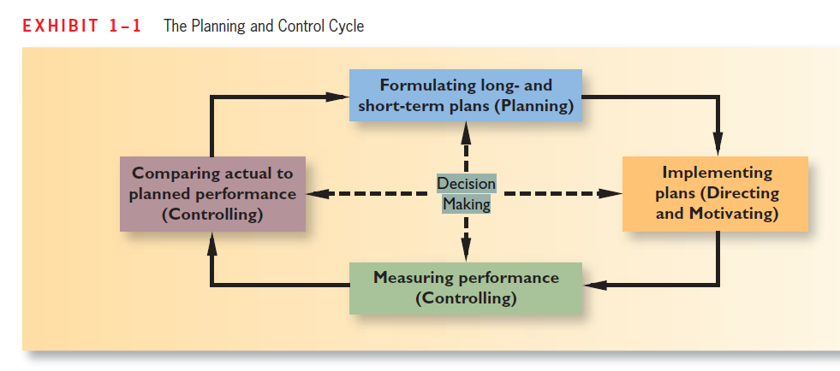
Goals of Managerial Accounting

The goal of managerial accounting is to provide information for internal decision making, primarily for planning and control purposes. The types of decisions made by managers rely substantially on accounting information. Because financial accounting information does not provide enough detail for internal decisions, it must be broken into more detail of the individual products or services provided by a company. Not only do managers need to know the cost of a product or service, they need the costs broken into smaller components so they are able to perform ‘what-if’ analyses and forecasts for the future. Some types of decisions that managers often make include pricing products, dropping a product or product line, buying new equipment to replace old, evaluating the performance of managers or divisions of a company, or making rather than buying a part or product. The two primary functions of managerial accounting are planning and controlling. Both of these help managers accomplish decision making.

As explained earlier, the work of management focuses on planning, which includes setting objectives and outlining how to attain these objectives, and control, which includes the steps taken to ensure that objectives are realized. To carry out these planning and control responsibilities, managers need information about the organization. From an accounting point of view, this information often relates to the costs of the organization. In managerial accounting, the term cost is used in many different ways. The reason is that there are many types of costs, and these costs are classified differently according to the immediate needs of management. For example, managers may want cost data to prepare external financial reports, to prepare planning budgets, or to make decisions. Each different use of cost data may demand a different kind of cost. For example, historical cost data is used to prepare external financial reports whereas decision making may require current cost data.

COMPARISON OF FINANCIAL AND MANAGERIAL ACCOUNTING
How does managerial accounting differ from financial accounting? Both provide information to users to make decisions. One difference between the two concerns which users for which the information is provided. Managerial accounting is concerned with providing information to managers—that is, the people inside an organization who direct and control its operations. Managerial accounting focuses on users inside the company. This internal group includes all levels of management, and sometimes various employee groups. In contrast, financial accounting is concerned with providing information to stockholders, creditors, and others who are outside/external to the organization. This contrast in orientation results in a number of major differences between financial and managerial accounting, even though they often rely on the same underlying financial data. Exhibit 1–2 summarizes these differences.

As shown in Exhibit 1–2 , financial and managerial accounting differ not only in their user orientation but also in their emphasis on the past and the future, in the type of data provided to users, and in several other ways. These differences are discussed in the following paragraphs.

Emphasis on the Future

Because planning is such an important part of the manager’s job, managerial accounting has a strong future orientation. In contrast, financial accounting primarily summarizes past financial transactions. These summaries may be useful in planning, but only to a point. The future is not simply a reflection of what has happened in the past. Changes are constantly taking place in economic conditions, customer needs and desires, competitive conditions, and so on. All of these changes demand that the manager’s planning be based in large part on estimates of what will happen rather than on summaries of what has already happened.

Relevance of Data

Financial accounting data should be objective and verifiable. However, for internal uses managers need information that is relevant even if it is not completely objective or verifiable. By relevant, we mean appropriate for the problem at hand. Managerial accounting should be flexible enough to provide whatever data are relevant for a particular decision.

Less Emphasis on Precision

Making sure that dollar amounts are accurate down to the last dollar or penny takes time and effort. While that kind of accuracy is required for external reports, most managers would rather have a good estimate immediately than wait for a more precise answer later. For this reason, managerial accountants often place less emphasis on precision than financial accountants do. For example, in a decision involving hundreds of millions of dollars, estimates that are rounded off to the nearest million dollars are probably good enough. In addition to placing less emphasis on precision than financial accounting, managerial accounting places much more weight on nonmonetary data. For example, data about customer satisfaction may be routinely used in managerial accounting reports.

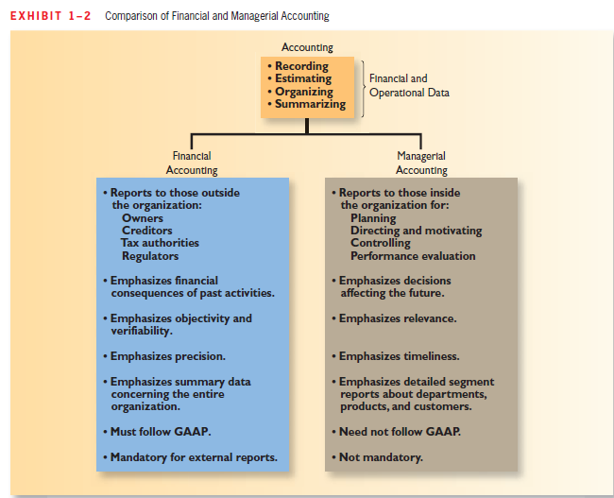

Segments of an Organization

Financial accounting is primarily concerned with reporting for the company as a whole. By contrast, managerial accounting focuses much more on the parts, or segments, of a company. These segments may be product lines, sales territories, divisions, departments, or any other categorization that management finds useful. Financial accounting does require some breakdowns of revenues and costs by major segments in external reports, but this is a secondary emphasis. In managerial accounting, segment reporting is the primary emphasis.

Generally Accepted Accounting Principles (GAAP)

Financial accounting statements prepared for external users must comply with generally accepted accounting principles (GAAP). External users must have some assurance that the reports have been prepared in accordance with a common set of ground rules. These common ground rules enhance comparability and help reduce fraud and misrepresentation, but they do not necessarily lead to the type of reports that would be most useful in internal decision making. However, GAAP requires that the land be stated at its original, historical cost on financial reports. The more relevant data for the decision—the current market value—is ignored under GAAP. While GAAP continues to shape financial reporting in the United States, most companies throughout the world are now communicating with their stakeholders using a different set of rules called International Financial Reporting Standards (IFRS). To better align U.S. reporting standards with the global community, the Securities and Exchange Commission (SEC) may eventually require all publicly traded companies in the U.S. to comply with IFRS instead of GAAP. Regardless of what the SEC decides to do, it is important to understand that managerial accounting is not bound by GAAP or IFRS. Managers set their own rules concerning the content and form of internal reports. The only constraint is that the expected benefits from using the information should outweigh the costs of collecting, analyzing, and summarizing the data. Nevertheless, as we shall see in subsequent chapters, it is undeniably true that financial reporting requirements have heavily influenced management accounting practice.

Managerial Accounting—Not Mandatory

Financial accounting is mandatory; that is, it must be done. Various outside parties such as the Securities and Exchange Commission (SEC) and the tax authorities require periodic financial statements. Managerial accounting, on the other hand, is not mandatory. A company is completely free to do as much or as little as it wishes. No regulatory bodies or other outside agencies specify what is to be done, or, for that matter, whether anything is to be done at all. Because managerial accounting is completely optional, the important question is always, “Is the information useful?” rather than, “Is the information required?”

