CHAPTER 2 COST TERMS AND CONCEPTS

CHAPTER OBJECTIVES
At the end of this chapter, students will be able to:
- Identify and give examples of each of the three basic manufacturing cost categories.
- Distinguish between product costs and period costs and give examples of each.
- Prepare an income statement including calculation of the cost of goods sold.
- Prepare a schedule of cost of goods manufactured.
- Understand the differences between variable costs and fixed costs.
- Understand the differences between direct and indirect costs.
- Understand cost classifications used in making decisions: differential costs, opportunity costs, and sunk costs.

CHAPTER CONTENTS
GENERAL COST CLASSIFICATIONS
- Manufacturing Costs
- Nonmanufacturing Costs
PRODUCT COSTS VERSUS PERIOD COSTS
- Product Costs
- Period Costs
- Prime Cost and Conversion Cost
COST CLASSIFICATIONS ON FINANCIAL STATEMENTS
- The Balance Sheet
- The Income Statement
- Schedule of Cost of Goods Manufactured
PRODUCT COST FLOWS
- Inventoriable Costs
- An Example of Cost Flows
COST CLASSIFICATIONS FOR PREDICTING COST BEHAVIOR
- Variable Cost
- Fixed Cost
COST CLASSIFICATIONS FOR ASSIGNING COSTS TO COST OBJECTS
- Direct Cost
- Indirect Cost
COST CLASSIFICATIONS FOR DECISION MAKING
- Differential Cost and Revenue
- Opportunity Cost
- Sunk Cost
CHAPTER INTRODUCTION
In managerial accounting, the term cost is used in many different ways. The reason is that there are many types of costs, and these costs are classified differently according to the immediate needs of management. For example, managers may want cost data to prepare external financial reports, to prepare planning budgets, or to make decisions. Each different use of cost data demands a different classification and definition of costs. For example, the preparation of external financial reports requires the use of historical cost data, whereas decision making may require predictions about future costs. This notion of different costs for different purposes is a critically important aspect of managerial accounting.

GENERAL COST CLASSIFICATIONS

We have chosen to start our discussion of cost concepts by focusing on manufacturing companies, because they are involved in most of the activities found in other types of organizations. Manufacturing companies such as Dire Dawa Food Complex S.C, Kombolcha Textile Factory, and National Cement Factory are involved in acquiring raw materials, producing finished goods, marketing, distributing, billing, and almost every other business activity. Therefore, an understanding of costs in a manufacturing company can be very helpful in understanding costs in other types of organizations.

In this chapter, we introduce cost concepts that apply to diverse organizations including fast-food outlets, movie studios, consulting firms, and your local hospitals. The exact terms used in these industries may not be the same as those used in manufacturing, but the same basic concepts apply. With some slight modifications, these basic concepts also apply to merchandising companies. With that in mind, let’s begin our discussion of manufacturing costs.

Manufacturing Costs

Most manufacturing companies separate manufacturing costs into three broad categories: direct materials, direct labor, and manufacturing overhead. A discussion of each of these categories follows.

Direct Materials

The materials that go into the final product are called raw materials. This term is somewhat misleading because it seems to imply unprocessed natural resources like wood pulp or iron ore. Actually, raw materials refer to any materials that are used in the final product; and the finished product of one company can become the raw materials of another company.

Raw materials may include both direct and indirect materials. Direct materials are those materials that become an integral part of the finished product and whose costs can be conveniently traced to the finished product.

Sometimes it isn’t worth the effort to trace the costs of relatively insignificant materials to end products. Such minor item would include the glue used to assemble a chair. Materials such as solder and glue are called indirect materials and are included as part of manufacturing overhead.

Direct Labor

Direct labor consists of labor costs that can be easily (i.e., physically and conveniently) traced to individual units of product. Direct labor is sometimes called touch labor because direct labor workers typically touch the product while it is being made. Examples of direct labor include assembly-line workers at Toyota, carpenters at the home builder, and electricians who install equipment on aircraft.

Labor costs that cannot be physically traced to particular products, or that can be traced only at great cost and inconvenience, are termed indirect labor. Just like indirect materials, indirect labor is treated as part of manufacturing overhead. Indirect labor includes the labor costs of janitors, supervisors, materials handlers, and night security guards. Although the efforts of these workers are essential, it would be either impractical or impossible to accurately trace their costs to specific units of product. Hence, such labor costs are treated as indirect labor.

Manufacturing Overhead

Manufacturing overhead, the third element of manufacturing cost, includes all manufacturing costs except direct materials and direct labor. Manufacturing overhead includes items such as indirect materials; indirect labor; maintenance and repairs on production equipment; and heat and light, property taxes, depreciation, and insurance on manufacturing facilities. A company also incurs costs for heat and light, property taxes, insurance, depreciation, and so forth, associated with its selling and administrative functions, but these costs are not included as part of manufacturing overhead. Only those costs associated with operating the factory are included in manufacturing overhead.

Various names are used for manufacturing overhead, such as indirect manufacturing cost, factory overhead, and factory burden. All of these terms are synonyms for manufacturing overhead.

Nonmanufacturing Costs

Nonmanufacturing costs are often divided into two categories: (1) selling costs and (2) administrative costs. Selling costs include all costs that are incurred to secure customer orders and get the finished product to the customer. These costs are sometimes called order-getting and order-filling costs. Examples of selling costs include advertising, shipping, sales travel, sales commissions, sales salaries, and costs of finished goods warehouses.

Administrative costs include all costs associated with the general management of an organization rather than with manufacturing or selling. Examples of administrative costs include executive compensation, general accounting, secretarial, public relations, and similar costs involved in the overall, general administration of the organization as a whole.

Nonmanufacturing costs are also often called selling, general, and administrative (SG&A) costs or just selling and administrative costs.

PRODUCT COSTS VERSUS PERIOD COSTS

In addition to classifying costs as manufacturing or nonmanufacturing costs, there are other ways to look at costs. For instance, they can also be classified as either product costs or period costs. To understand the difference between product costs and period costs, we must first discuss the matching principle from financial accounting.

Generally, costs are recognized as expenses on the income statement in the period that benefits from the cost. For example, if a company pays for liability insurance in advance for two years, the entire amount is not considered an expense of the year in which the payment is made. Instead, one-half of the cost would be recognized as an expense each year. The reason is that both years—not just the first year—benefit from the insurance payment. The unexpensed portion of the insurance payment is carried on the balance sheet as an asset called prepaid insurance.

The matching principle is based on the accrual concept that costs incurred to generate a particular revenue should be recognized as expenses in the same period that the revenue is recognized. This means that if a cost is incurred to acquire or make something that will eventually be sold, then the cost should be recognized as an expense only when the sale takes place—that is, when the benefit occurs. Such costs are called product costs.

Product Costs

For financial accounting purposes, product costs include all costs involved in acquiring or making a product. In the case of manufactured goods, these costs consist of direct materials, direct labor, and manufacturing overhead. Product costs “attach” to units of product as the goods are purchased or manufactured and they remain attached as the goods go into inventory awaiting sale. Product costs are initially assigned to an inventory account on the balance sheet. When the goods are sold, the costs are released from inventory as expenses (typically called cost of goods sold) and matched against sales revenue. Because product costs are initially assigned to inventories, they are also known as inventoriable costs.

We want to emphasize that product costs are not necessarily treated as expenses in the period in which they are incurred. Rather, as explained above, they are treated as expenses in the period in which the related products are sold. This means that a product cost such as direct materials or direct labor might be incurred during one period but not recorded as an expense until a following period when the completed product is sold.

Period Costs

Period costs are all the costs that are not product costs. For example, sales commissions and the rental costs of administrative offices are period costs. Period costs are not included as part of the cost of either purchased or manufactured goods; instead, period costs are expensed on the income statement in the period in which they are incurred using the usual rules of accrual accounting. Keep in mind that the period in which a cost is incurred is not necessarily the period in which cash changes hands. For example, as discussed earlier, the costs of liability insurance are spread across the periods that benefit from the insurance—regardless of the period in which the insurance premium is paid.

As suggested above, all selling and administrative expenses are considered to be period costs. Advertising, executive salaries, sales commissions, public relations, and other nonmanufacturing costs discussed earlier are all examples of period costs. They will appear on the income statement as expenses in the period in which they are incurred.

Prime Cost and Conversion Cost

Two more cost categories are often used in discussions of manufacturing costs— prime cost and conversion cost. Prime cost is the sum of direct materials cost and direct labor cost. Conversion cost is the sum of direct labor cost and manufacturing overhead cost. The term conversion cost is used to describe direct labor and manufacturing overhead because these costs are incurred to convert materials into the finished product.

Exhibit 2–1 contains a summary of the cost terms that we have introduced so far.

Exhibit 2 – 1 Summary of Cost Terms

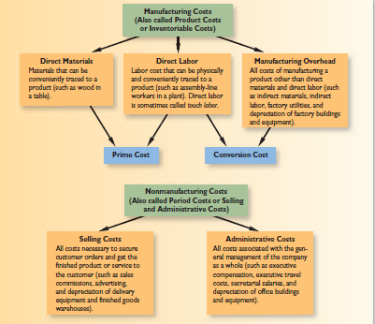

COST CLASSIFICATIONS ON FINANCIAL STATEMENTS

In this section of the chapter, we compare the cost classifications used on the financial statements of manufacturing and merchandising companies. The financial statements prepared by a manufacturing company are more complex than the statements prepared by a merchandising company because a manufacturing company must produce its goods as well as market them. The production process involves many costs that do not exist in a merchandising company, and these costs must be properly accounted for on the manufacturing company’s financial statements. We begin by explaining how these costs are shown on the balance sheet.

The Balance Sheet

The balance sheet or statement of financial position, of a manufacturing company is similar to that of a merchandising company. However, their inventory accounts differ. A merchandising company has only one class of inventory—goods purchased from suppliers for resale to customers. In contrast, manufacturing companies have three classes of inventories— raw materials, work in process, and finished goods. Raw materials are the materials that are used to make a product. Work in process consists of units of product that are only partially complete and will require further work before they are ready for sale to a customer. Finished goods consist of completed units of product that have not yet been sold to customers. Ordinarily, the sum total of these three categories of inventories is the only amount shown on the balance sheet in external reports. However, the footnotes to the financial statements often provide more detail.

We will use two companies—Graham Manufacturing and Reston Bookstore—to illustrate the concepts discussed in this section.

The footnotes to Graham Manufacturing’s Annual Report reveal the following information concerning its inventories:

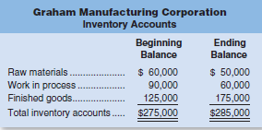

In contrast, the inventory account at Reston Bookstore consists entirely of the costs of books the company has purchased from publishers for resale to the public. In merchandising companies like Reston, these inventories may be called merchandise inventory. The beginning and ending balances in this account appear as follows:

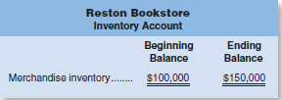
The Income Statement

Exhibit 2–2 compares the income statements of Reston Bookstore and Graham Manufacturing. For purposes of illustration, these statements contain more detail about cost of goods sold than you will generally find in published financial statements.

Exhibit 2–2 Comparative Income Statements: Merchandising and Manufacturing Companies

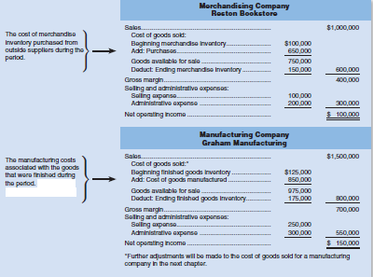
At first glance, the income statements of merchandising and manufacturing companies like Reston Bookstore and Graham Manufacturing are very similar. The only apparent difference is in the labels of some of the entries in the computation of the cost of goods sold. In the exhibit, the computation of cost of goods sold relies on the following basic equation for inventory accounts:

The logic underlying this equation, which applies to any inventory account, is illustrated in Exhibit 2–3. The beginning inventory consists of any units that are in the inventory at the beginning of the period. Additions are made to the inventory during the period. The sum of the beginning balance and the additions to the account is the total amount of inventory available. During the period, withdrawals are made from inventory. The ending balance is whatever is left at the end of the period after the withdrawals.

Exhibit 2 – 3 Inventory Flows

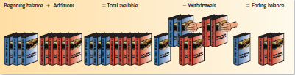

These concepts are used to determine the cost of goods sold for a merchandising company like Reston Bookstore as follows:

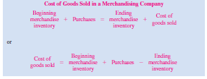

To determine the cost of goods sold in a merchandising company, we only need to know the beginning and ending balances in the Merchandise Inventory account and the purchases. Total purchases can be easily determined in a merchandising company by simply adding together all purchases from suppliers.

The cost of goods sold for a manufacturing company like Graham Manufacturing is determined as follows:

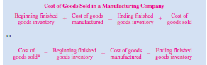

To determine the cost of goods sold in a manufacturing company, we need to know the cost of goods manufactured and the beginning and ending balances in the Finished Goods inventory account. The cost of goods manufactured consists of the manufacturing costs associated with goods that were finished during the period. The cost of goods manufactured for Graham Manufacturing is derived in the schedule of cost of goods manufactured shown in Exhibit 2– 4.

Schedule of Cost of Goods Manufactured

At first glance, the schedule of cost of goods manufactured in Exhibit 2–6 appears complex and perhaps even intimidating. However, it is all quite logical. The schedule of cost of goods manufactured contains the three elements of product costs that we discussed earlier—direct materials, direct labor, and manufacturing overhead.

The direct materials cost of $410,000 is not the cost of raw materials purchased during the period—it is the cost of raw materials used during the period. The purchases of raw materials are added to the beginning balance to determine the cost of the materials available for use. The ending raw materials inventory is deducted from this amount to arrive at the cost of raw materials used in production. The sum of the three manufacturing cost elements—materials, direct labor, and manufacturing overhead—is the total manufacturing cost of $820,000. However, you’ll notice that this is not the same thing as the cost of goods manufactured for the period of $850,000. The subtle distinction between the total manufacturing cost and the cost of goods manufactured is very easy to miss. Some of the materials, direct labor, and manufacturing overhead costs incurred during the period relate to goods that are not yet completed. As stated above, the cost of goods manufactured consists of the manufacturing costs associated with the goods that were finished during the period. Consequently, adjustments need to be made to the total manufacturing cost of the period for the partially completed goods that were in process at the beginning and at the end of the period. The costs that relate to goods that are not yet completed are shown in the work in process inventory figures at the bottom of the schedule. Note that the beginning work in process inventory must be added to the manufacturing costs of the period, and the ending work in process inventory must be deducted, to arrive at the cost of goods manufactured. The $30,000 decline in the Work in Process account during the year ($90,000 − $60,000) explains the $30,000 difference between the total manufacturing cost and the cost of goods manufactured.

Exhibit 2 – 4 Schedule of Cost of Goods Manufactured

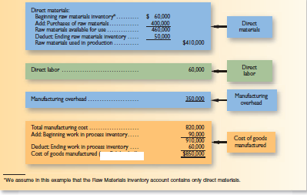

PRODUCT COST FLOWS
Earlier in the chapter, we defined product costs as costs incurred to either purchase or manufacture goods. For manufactured goods, these costs consist of direct materials, direct labor, and manufacturing overhead. It will be helpful at this point to look briefly at the flow of costs in a manufacturing company. This will help us understand how product costs move through the various accounts and how they affect the balance sheet and the income statement.

Exhibit 2–5 illustrates the flow of costs in a manufacturing company. Raw materials purchases are recorded in the Raw Materials inventory account. When raw materials are used in production, their costs are transferred to the Work in Process inventory account as direct materials. Notice that direct labor cost and manufacturing overhead cost are added directly to Work in Process. Work in Process can be viewed most simply as products on an assembly line. The direct materials, direct labor, and manufacturing overhead costs added to Work in Process in Exhibit 2 - 7 are the costs needed to complete these products as they move along this assembly line.

Notice from the exhibit that as goods are completed, their costs are transferred from Work in Process to Finished Goods. Here the goods await sale to customers. As goods are sold, their costs are transferred from Finished Goods to Cost of Goods Sold. At this point the various costs required to make the product are finally recorded as an expense. Until that point, these costs are in inventory accounts on the balance sheet.

Exhibit 2 – 5 Cost Flows and Classifications in a Manufacturing Company
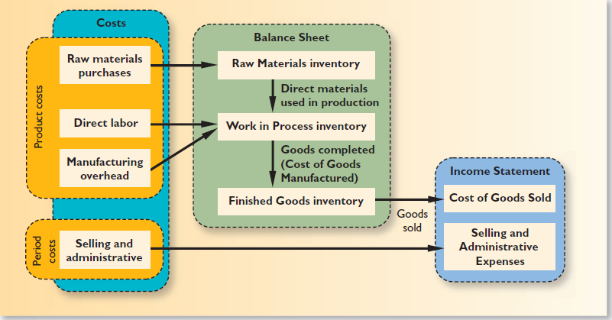
Inventoriable Costs

As stated earlier, product costs are often called inventoriable costs. The reason is that these costs go directly into inventory accounts as they are incurred (first into Work in Process and then into Finished Goods), rather than going into expense accounts. Thus, they are termed inventoriable costs. This is a key concept because such costs can end up on the balance sheet as assets if goods are only partially completed or are unsold at the end of a period. To illustrate this point, refer again to Exhibit 2– 5. At the end of the period, the materials, labor, and overhead costs that are associated with the units in the Work in Process and Finished Goods inventory accounts will appear on the balance sheet as assets. As explained earlier, these costs will not become expenses until the goods are completed and sold.

Selling and administrative expenses are not involved in making a product. For this reason, they are not treated as product costs but rather as period costs that are expensed as they are incurred, as shown in Exhibit 2–5.

COST CLASSIFICATIONS FOR PREDICTING COST BEHAVIOR

Quite frequently, it is necessary to predict how a certain cost will behave in response to a change in activity. Cost behavior refers to how a cost reacts to changes in the level of activity. As the activity level rises and falls, a particular cost may rise and fall as well—or it may remain constant. For planning purposes, a manager must be able to anticipate which of these will happen; and if a cost can be expected to change, the manager must be able to estimate how much it will change. To help make such distinctions, costs are often categorized as variable or fixed.

Variable Cost

A variable cost is a cost that varies, in total, in direct proportion to changes in the level of activity. The activity can be expressed in many ways, such as units produced, units sold, miles driven, beds occupied, lines of print, hours worked, and so forth. A good example of a variable cost is direct materials. The cost of direct materials used during a period will vary, in total, in direct proportion to the number of units that are produced. To illustrate this idea, consider the Saturn Division of GM. Each auto requires one battery. As the output of autos increases and decreases, the number of batteries used will increase and decrease proportionately. If auto production goes up 10%, then the number of batteries used will also go up 10%. The concept of a variable cost is shown graphically in Exhibit 2–6.

The graph on the left-hand side of Exhibit 2–6 illustrates that the total variable cost rises and falls as the activity level rises and falls. This idea is presented below, assuming that a Saturn’s battery costs $24:

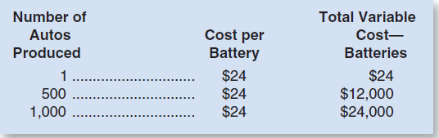

While total variable costs change as the activity level changes, it is important to note that a variable cost is constant if expressed on a per unit basis. For example, the per unit cost of batteries remains constant at $24 even though the total cost of the batteries increases and decreases with activity.

There are many examples of costs that are variable with respect to the products and services provided by a company. In a manufacturing company, variable costs include items such as direct materials, shipping costs, and sales commissions and some elements of manufacturing overhead such as lubricants. We will also usually assume that direct labor is a variable cost, although direct labor may act more like a fixed cost in some situations. In a merchandising company, the variable costs of carrying and selling products include items such as cost of goods sold, sales commissions, and billing costs. In a hospital, the variable costs of providing health care services to patients would include the costs of the supplies, drugs, meals, and perhaps nursing services.

When we say that a cost is variable, we ordinarily mean that it is variable with respect to the amount of goods or services the organization produces. This could be how many Jeep Cherokees are produced, how many videos are rented, how many patients are treated, and so on. However, costs can be variable with respect to other things.

Fixed Cost

A fixed cost is a cost that remains constant, in total, regardless of changes in the level of activity. Unlike variable costs, fixed costs are not affected by changes in activity. Consequently, as the activity level rises and falls, total fixed costs remain constant unless influenced by some outside force, such as a price change. Rent is a good example of a fixed cost. Suppose the Mayo Clinic rents a machine for $8,000 per month that tests blood samples for the presence of leukemia cells. The $8,000 monthly rental cost will be incurred regardless of the number of tests that may be performed during the month. The concept of a fixed cost is shown graphically on the right-hand side of Exhibit 2–6.

Very few costs are completely fixed. Most will change if activity changes enough. For example, suppose that the capacity of the leukemia diagnostic machine at the Mayo Clinic is 2,000 tests per month. If the clinic wishes to perform more than 2,000 tests in a month, it would be necessary to rent an additional machine, which would cause a jump in the fixed costs. When we say a cost is fixed, we mean it is fixed within some relevant range. The relevant range is the range of activity within which the assumptions about variable and fixed costs are valid. For example, the assumption that the rent for diagnostic machines is $8,000 per month is valid within the relevant range of 0 to 2,000 tests per month.

Fixed costs can create confusion if they are expressed on a per unit basis. This is because the average fixed cost per unit increases and decreases inversely with changes in activity. In the Mayo Clinic, for example, the average cost per test will fall as the number of tests performed increases because the $8,000 rental cost will be spread over more tests. Conversely, as the number of tests performed in the clinic declines, the average cost per test will rise as the $8,000 rental cost is spread over fewer tests. This concept is illustrated in the table below:

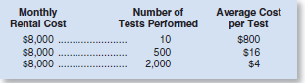

Note that if the Mayo Clinic performs only 10 tests each month, the rental cost of the equipment will average $800 per test. But if 2,000 tests are performed each month, the average cost will drop to only $4 per test.

Examples of fixed costs include straight-line depreciation, insurance, property taxes, rent, supervisory salaries, administrative salaries, and advertising.

Exhibit 2–6 Variable and Fixed Cost Behavior

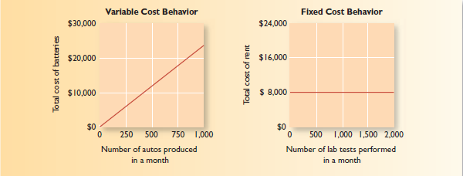

A summary of both variable and fixed cost behavior is presented in Exhibit 2–7.

Exhibit 2–7 Summary of Variable and Fixed Cost Behavior

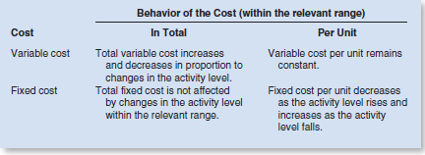

COST CLASSIFICATIONS FOR ASSIGNING COSTS TO COST OBJECTS

Costs are assigned to cost objects for a variety of purposes including pricing, preparing profitability studies, and controlling spending. A cost object is anything for which cost data are desired—including products, customers, jobs, and organizational subunits. For purposes of assigning costs to cost objects, costs are classified as either direct or indirect.

Direct Cost

A direct cost is a cost that can be easily and conveniently traced to a specified cost object. The concept of direct cost extends beyond just direct materials and direct labor. For example, if Reebok is assigning costs to its various regional and national sales offices, then the salary of the sales manager in its Tokyo office would be a direct cost of that office.

Indirect Cost

An indirect cost is a cost that cannot be easily and conveniently traced to a specified cost object. For example, a Campbell Soup factory may produce dozens of varieties of canned soups. The factory manager’s salary would be an indirect cost of a particular variety such as chicken noodle soup. The reason is that the factory manager’s salary is incurred as a consequence of running the entire factory—it is not incurred to produce any one soup variety. To be traced to a cost object such as a particular product, the cost must be caused by the cost object. The factory manager’s salary is called a common cost of producing the various products of the factory. A common cost is a cost that is incurred to support a number of cost objects but cannot be traced to them individually. A common cost is a type of indirect cost.

A particular cost may be direct or indirect, depending on the cost object. While the Campbell Soup factory manager’s salary is an indirect cost of manufacturing chicken noodle soup, it is a direct cost of the manufacturing division. In the first case, the cost object is chicken noodle soup. In the second case, the cost object is the entire manufacturing division.

COST CLASSIFICATIONS FOR DECISION MAKING

Costs are an important feature of many business decisions. In making decisions, it is essential to have a firm grasp of the concepts differential cost, opportunity cost, and sunk cost.

Differential Cost and Revenue

Decisions involve choosing between alternatives. In business decisions, each alternative will have costs and benefits that must be compared to the costs and benefits of the other available alternatives. A difference in costs between any two alternatives is known as a differential cost.

A difference in revenues between any two alternatives is known as differential revenue. A differential cost is also known as an incremental cost , although technically an incremental cost should refer only to an increase in cost from one alternative to another; decreases in cost should be referred to as decremental costs. Differential cost is a broader term, encompassing both cost increases (incremental costs) and cost decreases (decremental costs) between alternatives.

The accountant’s differential cost concept can be compared to the economist’s marginal cost concept. In speaking of changes in cost and revenue, the economist uses the terms marginal cost and marginal revenue. The revenue that can be obtained from selling one more unit of product is called marginal revenue, and the cost involved in producing one more unit of product is called marginal cost. The economist’s marginal concept is basically the same as the accountant’s differential concept applied to a single unit of output.

Differential costs can be either fixed or variable. To illustrate, assume that Nature Way Cosmetics, Inc., is thinking about changing its marketing method from distribution through retailers to distribution by a network of neighborhood sales representatives. Present costs and revenues are compared to projected costs and revenues in the following table:

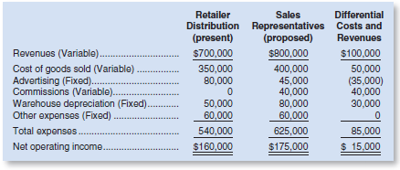

According to the above analysis, the differential revenue is $100,000 and the differential costs total $85,000, leaving a positive differential net operating income of $15,000 under the proposed marketing plan.

The decision of whether Nature Way Cosmetics should stay with the present retail distribution or switch to sales representatives could be made on the basis of the net operating incomes of the two alternatives. As we see in the above analysis, the net operating income under the present distribution method is $160,000, whereas the net operating income with sales representatives is estimated to be $175,000. Therefore, using sales representatives is preferred because it would result in $15,000 higher net operating income. Note that we would have arrived at exactly the same conclusion by simply focusing on the differential revenues, differential costs, and differential net operating income, which also show a $15,000 advantage for sales representatives.

In general, only the differences between alternatives are relevant in decisions. Those items that are the same under all alternatives and that are not affected by the decision can be ignored. For example, in the Nature Way Cosmetics example above, the “Other expenses” category, which is $60,000 under both alternatives, can be ignored because it has no effect on the decision. If it were removed from the calculations, the sales representatives would still be preferred by $15,000. This is an extremely important principle in management accounting.

Opportunity Cost

Opportunity cost is the potential benefit that is given up when one alternative is selected over another. To illustrate this important concept, consider the following examples:

Example 1 Vicki has a part-time job that pays $200 per week while attending college. She would like to spend a week at the beach during spring break, and her employer has agreed to give her the time off, but without pay. The $200 in lost wages would be an opportunity cost of taking the week off to be at the beach.

Example 2 Suppose that Neiman Marcus is considering investing a large sum of money in land that may be a site for a future store. Rather than invest the funds in land, the company could invest the funds in high-grade securities. The opportunity cost of buying the land is the investment income that could have been realized by purchasing the securities instead.

Example 3 Steve is employed by a company that pays him a salary of $38,000 per year. He is thinking about leaving the company and returning to school. Because returning to school would require that he give up his $38,000 salary, the forgone salary would be an opportunity cost of seeking further education.

Opportunity costs are not usually found in accounting records, but they are costs that must be explicitly considered in every decision a manager makes. Virtually every alternative involves an opportunity cost.

Sunk Cost

A sunk cost is a cost that has already been incurred and that cannot be changed by any decision made now or in the future. Because sunk costs cannot be changed by any decision, they are not differential costs. And because only differential costs are relevant in a decision, sunk costs can and should be ignored.

To illustrate a sunk cost, assume that a company paid $50,000 several years ago for a special-purpose machine. The machine was used to make a product that is now obsolete and is no longer being sold. Even though in hindsight purchasing the machine may have been unwise, the $50,000 cost has already been incurred and cannot be undone. And it would be folly to continue making the obsolete product in a misguided attempt to “recover” the original cost of the machine. In short, the $50,000 originally paid for the machine is a sunk cost that should be ignored in current decisions.

