***CHAPTER 2 MASTER BUDGET AND RESPONSIBILITY ACCOUNTING***

In this chapter, we focus on the stepstaken by businesses to achieve their planned levels of profits—a process called *profit planning.* We shall see that profit planning is accomplished through the preparation of a number of budgets, which, when brought together, form an integrated business plan known as the *master budget.* The master budget is an essential management tool that communicates management’s plans throughout the organization, allocates resources, and coordinates activities.

**LEARNING OBJECTIVE 1** Understand why organizationsbudget and the processes theyuse to create budgets.

**The Basic Framework of Budgeting**

A **budget** is a detailed plan for acquiring and using financial and other resources over a specified time period. It represents a plan for the future expressed in formal quantitative terms. The act of preparing a budget is called *budgeting.* The use of budgets to control an organization’s activities is known as *budgetary control.*

The **master budget** is a summary of a company’s plans that sets specific targets for sales, production, distribution, and financing activities. It generally culminates in a cash budget, a budgeted income statement, and a budgeted balance sheet. In short, it represents a comprehensive expression of management’s plans for the future and how these plans are to be accomplished.

***Personal Budgets***

Nearly everyone budgets to some extent, even though many of the people who use budgets do not recognize what they are doing as budgeting. For example, most people make estimates of their income and plan expenditures for food, clothing, housing, and so on. As a result of this planning, people restrict their spending to some predetermined, allowable amount. While they may not be conscious of the fact, these people clearly go through a budgeting process. Income is estimated, expenditures are planned, and spending is restricted in accordance with the plan. Individuals also use budgets to forecast their future financial condition for purposes such as purchasing a home, financing college education, or setting aside funds for retirement. These budgets may exist only in the mind of the individual, but they are budgets nevertheless.

The budgets of a business or other organization serve much the same functions as the budgets prepared informally by individuals. Business budgets tend to be more detailed and to involve more work, but they are similar to the budgets prepared by individuals in most other respects. Like personal budgets, they assist in planning and controlling expenditures; they also assist in predicting operating results and financial condition in future periods.

***Difference between Planning and Control***

The terms *planning* and *control* are often confused, and occasionally are used as though they mean the same thing. Actually, planning and control are two quite distinct concepts. **Planning** involves developing objectives and preparing various budgets to achieve those objectives. **Control** involves the steps taken by management to increase the likelihood that the objectives set down at the planning stage are attained and that all parts of the organization are working together toward that goal. To be completely effective, a good budgeting system must provide for *both* planning and control. Good planning without effective control is time wasted.

***Advantages of Budgeting***

Companies realize many benefits from a budgeting program. Among these benefits are the following:

1. Budgets *communicate* management’s plans throughout the organization.
2. Budgets force managers to *think about* and plan for the future. In the absence of the necessity to prepare a budget, many managers would spend all of their time dealing with daily emergencies.
3. The budgeting process provides a means of *allocating resources* to those parts of the organization where they can be used most effectively.
4. The budgeting process can uncover potential *bottlenecks* before they occur.
5. Budgets *coordinate* the activities of the entire organization by *integrating* the plans of its various parts. Budgeting helps to ensure that everyone in the organization is pulling in the same direction.
6. Budgets define goals and objectives that can serve as *benchmarks* for evaluating subsequent performance.

***Responsibility Accounting***

The basic idea underlying **responsibility accounting** is that amanager should be held responsible for those items - and *only* those items - that the managercan actually control to a significant extent. Each line item (i.e., revenue or cost) inthe budget is made the responsibility of a manager, and that manager is held responsiblefor subsequent deviations between budgeted goals and actual results. In effect, responsibilityaccounting *personalizes* accounting information by looking at revenues and costsfrom a *personal control* standpoint. This concept is central to any effective profit planningand control system. Someone must be held responsible for each cost or else no one willbe responsible and the cost will inevitably grow out of control.

Being held responsible for financial performance does not mean that the manager is penalized if actual results do not measure up to the budgeted goals. However, the manager should take the initiative to correct any unfavorable discrepancies, should understand the source of significant favorable or unfavorable discrepancies, and should be prepared to explain the reasons for discrepancies to higher management. The point of an effective responsibility accounting system is to make sure that nothing “falls through the cracks,” that the organization reacts quickly and appropriately to deviations from its plans, and that the organization learns from the feedback it gets by comparing budgeted goals to actual results. The point is not to penalize individuals for missing targets.

***Choosing a Budget Period***

Operating budgets ordinarily cover a one-year period corresponding to the company’s fiscal year. Many companies divide their budget year into four quarters. The first quarter is then subdivided into months, and monthly budgets are developed. The last three quarters may be carried in the budget as quarterly totals only. As the year progresses, the figures for the second quarter are broken down into monthly amounts, then the third-quarter figures are broken down, and so forth. This approach has the advantage of requiring periodic review and reappraisal of budget data throughout the year.

*Continuous* or *perpetual budgets* are used by a significant number of organizations. A **continuous** or **perpetual budget** is a 12-month budget that rolls forward one month (or quarter) as the current month (or quarter) is completed. In other words, one month (or quarter) is added to the end of the budget as each month (or quarter) comes to a close. This approach keeps managers focused on the future at least one year ahead. Advocates of continuous budgets argue that with this approach there is less danger that managers will become too narrowly focused on short-term results.



***The Self-Imposed Budget***

The success of a budget program will be largely determined by the way in which the budget is developed. In the most successful budget programs, managers actively participate in preparing their own budgets. This is in contrast to the approach in which budgets are imposed from above. The participative approach to preparing budgets is particularly important if the budget is to be used to control and evaluate a manager’s performance. If a budget is imposed on a manager from above, it will probably generate resentment rather than cooperation and commitment.

The budgeting approach in which managers prepare their own budget estimates— called a *self-imposed budget*—is generally considered to be the most effective method of budget preparation. A **self-imposed budget** or **participative budget** is a budget that is prepared with the full cooperation and participation of managers at all levels.

A number of advantages are commonly cited for such self-imposed budgets:

1. Individuals at all levels of the organization are recognized as members of the team whose views and judgments are valued by top management.
2. Budget estimates prepared by front-line managers are often more accurate and reliable than estimates prepared by top managers who have less intimate knowledge of markets and day-to-day operations.
3. Motivation is generally higher when individuals participate in setting their own goals than when the goals are imposed from above. Self-imposed budgets create commitment.
4. A manager who is not able to meet a budget that has been imposed from above can always say that the budget was unrealistic and impossible to meet. With a self imposed budget, this excuse is not available.

**E X H I B I T 1 – 1** The Initial Flow of Budget Data in aParticipative Budgeting System



The initial flow of budget data in a participative system is from lower levels of responsibility to higher levels of responsibility. Each person with responsibility for cost control will prepare his or her own budget estimates and submit them to the next higher level of management. These estimates are reviewed and consolidated as they move upward in the organization.

Once self-imposed budgets are prepared, are they subject to any kind of review? The answer is yes. Budget estimates prepared by lower-level managers should be scrutinized by higher levels of management. Without such a review, self-imposed budgets may be too loose and allow too much “budgetary slack.” The result will be inefficiency and waste. Therefore, before budgets are accepted, they must be carefully reviewed by immediate superiors. If changes from the original budget seem desirable, the items in question are discussed and modified as necessary.

In essence, all levels of an organization should work together to produce the budget. Since top management is generally unfamiliar with detailed, day-to-day operations, it should rely on subordinates to provide detailed budget data. On the other hand, top management has an overall strategic perspective that is also vital. Each level of responsibility in an organization should contribute its unique knowledge and perspective in a *cooperative* effort to develop an integrated budget.

To be successful, a self-imposed approach to setting budgets requires that all managers understand and agree with the organization’s strategy. Otherwise, the budgets proposed by the lower-level managers will lack coherent direction.

***Human Factors in Budgeting***

The success of a budget program depends on three important factors:

1. Top management must be enthusiastic and committed to the budget process.
2. Top management must not use the budget to pressure employees or blame them when   
    something goes wrong.
3. Highly achievable budget targets are usually preferred when managers are rewarded based on meeting budget targets.

***The Budget Committee***

A standing committee responsible for

* + overall policy matters relating to the budget
  + coordinating the preparation of the budget
  + resolving disputes related to the budget
  + approving the final budget

***The Master Budget: An Overview***

The master budget consists of a number of separate but interdependent budgets. Exhibit 1–2 provides an overview of the various parts of the master budget and how they are related.

E X H I B I T 1 – 2 The Master Budget Interrelationships



**The Sales Budget**

A **sales budget** is a detailed schedule showing the expected sales for the budget period; typically, it is expressed in both dollars and units. An accurate sales budget is the key to the entire budgeting process. All of the other parts of the master budget are dependent on the sales budget, as illustrated in Exhibit 1–2. Thus, if the sales budget is sloppily done, then the rest of the budgeting process is largely a waste of time.

The sales budget helps determine how many units need to be produced. Thus, the production budget is prepared after the sales budget. The production budget in turn is used to determine the budgets for manufacturing costs including the direct materials budget, the direct labor budget, and the manufacturing overhead budget. These budgets are then combined with data from the sales budget and the selling and administrative expense budget to determine the cash budget. In essence, the sales budget triggers a chain reaction that leads to the development of the other budgets.

As shown in Exhibit 1- 2, the **selling and administrative expense budget** is both dependent on and a determinant of the sales budget. This reciprocal relationship arises because sales will in part be determined by the funds committed to advertising and sales promotion.

**The Cash Budget**

Once the operating budgets (sales, production, and so on) have been established, the cash budget and other financial budgets can be prepared. A cash budget is a detailed plan showing how cash resources will be acquired and used over some specified time period. Observe from Exhibit 9–2 that all of the operating budgets have an impact on the cash budget. In the case of the sales budget, the impact comes from the planned cash receipts to be received from sales. In the case of the other budgets, the impact comes from the planned cash expenditures within the budgets themselves.

**Sales Forecasting—A Critical Step**

The sales budget is usually based on the company’s sales forecast. Sales from prior years are commonly used as a starting point in preparing the sales forecast. In addition, the analyst may examine the company’s unfilled back orders; the company’s pricing policy and marketing plans, trends in the industry, and general economic conditions. Sophisticated statistical tools may be used to analyze the data and to build models that are helpful in predicting key factors influencing the company’s sales.

**Preparing the Master Budget**

1. A sales budget, including a schedule of expected cash collections.
2. A production budget (a merchandise purchases budget would be used in a merchandising company).
3. A direct materials budget, including a schedule of expected cash disbursements for raw materials.
4. A direct labor budget.
5. A manufacturing overhead budget.
6. An ending finished goods inventory budget.
7. A selling and administrative expense budget.
8. A cash budget.
9. A budgeted income statement.
10. A budgeted balance sheet.

**LEARNING OBJECTIVE 2** Prepare a sales budget, including a schedule of expected cash collections.

**The Sales Budget**

The sales budget is the starting point in preparing the master budget. As shown earlier in Exhibit 1–2, all other items in the master budget, including production, purchases, inventories, and expenses, depend on it.

The sales budget is constructed by multiplying the budgeted sales in units by the selling price.

* Budgeting Example
* Royal Company is preparing budgets for the quarter ending June 30.
* Budgeted sales for the next five months are:
  + **April 20,000 units**
  + **May 50,000 units**
  + **June 30,000 units**
  + **July 25,000 units**
  + **August 15,000 units.**
* The selling price is $10 per unit.

Let’s prepare sales budget for Royal Company for the quarter ending June 30.

The individual months of April, May, and June are summed to obtain the total budgeted sales in units and dollars for the quarter ended June 30th

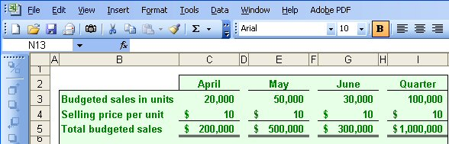

**Schedule of Expected Cash Collections**

A schedule of expected cash collections is prepared after the sales budget. This schedule will be needed later to prepare the cash budget. Cash collections consist of collections on credit sales made to customers in prior periods plus collections on sales made in the current budget period.

Example: Consider the sales budget and the following additional information for Royal Company

* All sales are on account.
* Royal’s collection pattern is:
  + 70% collected in the month of sale,
  + 25% collected in the month following sale,
  + 5% uncollectible.
* The March 31 accounts receivable balance of $30,000 will be collected in full.

Let’s prepare schedule of expected cash collections for Royal Company for the quarter ending June 30.

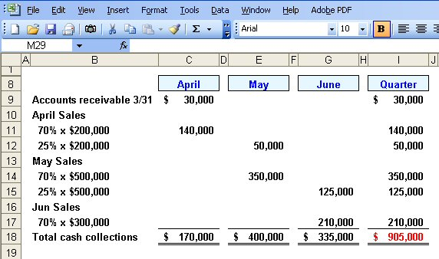

**Learning Objective 3** Prepare a production budget

**The Production Budget**

The production budget is prepared after the sales budget. The **production budget** lists the number of units that must be produced during each budget period to meet sales needs and to provide for the desired ending inventory. Production needs can be determined as follows:

Budgeted unit sales XXXX

Add desired ending inventory XXXX

Total needs XXXX

Less beginning inventory XXXX

Required production XXXX

Note that production requirements for a quarter are influenced by the desired level of the ending inventory. Inventories should be carefully planned. Excessive inventories tie up funds and create storage problems. Insufficient inventories can lead to lost sales, high-cost crash production efforts.

**Example:**

* The management at Royal Company wants ending inventory to be equal to *20%* of the following month’s budgeted sales in units.
* On March 31, 4,000 units were on hand.

Let’s prepare the production budget for Royal Company for the quarter ending June 30.

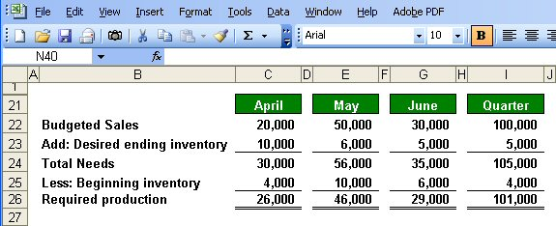

**Learning Objective 4** Prepare a direct materials budget, including a schedule of expected cash disbursements for purchases of materials.

***Inventory Purchases—Merchandising Company***

Royal Company prepares a production budget, since it is a *manufacturing* company. If it were a *merchandising* company, it would instead prepare a **merchandise purchases** **budget** showing the amount of goods to be purchased from its suppliers during the period. The merchandise purchases budget has the same basic format as the production budget, as shown below:

Budgeted sales XXXXX

Add desired ending merchandise inventory XXXXX

Total needs XXXXX

Less beginning merchandise inventory XXXXX

Required purchases XXXXX

A merchandising company would prepare a merchandise purchases budget such as the one above for each item carried in stock. The merchandise purchases budget can be expressed in terms of either units or the purchase cost of those units.

**LEARNING OBJECTIVE 4** Prepare a direct materialsbudget, including a schedule ofexpected cash disbursementsfor purchases of materials.

***The Direct Materials Budget***

Returning to Royal Company after the production requirements have been computed, a *direct materials budget* can be prepared. The **direct materials budget** details the raw materials that must be purchased to fulfill the production budget and to provide for adequate inventories. The required purchases of raw materials are computed as follows:

Raw materials needed to meet the production schedule XXXXX

Add desired ending inventory of raw materials XXXXX

Total raw materials needs XXXXX

Less beginning inventory of raw materials XXXXX

Raw materials to be purchased XXXXX

**Example:**

* At Royal Company, *five pounds* of material are required per unit of product.
* Management wants materials on hand at the end of each month equal to *10%* of the following month’s production.
* On March 31, 13,000 pounds of material are on hand. Material cost is *$0.40* per pound.

Let’s prepare the direct materials budget for Royal Company for the quarter ending June 30.

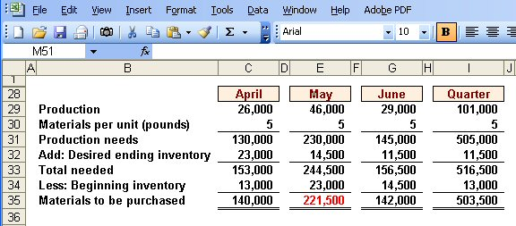

**Schedule of expected cash disbursements for purchases of materials**

The direct materials budget (and the merchandise purchases budget for a merchandising company) is usually accompanied by a schedule of expected cash disbursements for raw materials (or merchandise purchases). This schedule is needed to prepare the overall cash budget. Disbursements for raw materials (or merchandise purchases) consist of payments for purchases on account in prior periods plus any payments for purchases in the current budget period.

**Example:**

* Royal pays *$0.40 per pound* for its materials.
* *One-half* of a month’s purchases is paid for in the month of purchase; the other half is paid in the following month.
* The March 31 accounts payable balance is $12,000.

Let’s calculate expected cash disbursements for Royal Company for the quarter ending June 30.

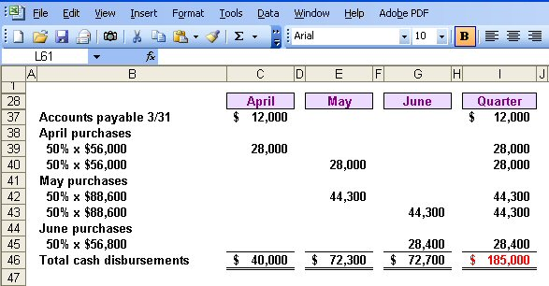

**LEARNING OBJECTIVE 5** Prepare a direct labor budget.

***The Direct Labor Budget***

The **direct labor budget** is also developed from the production budget. Direct labor requirements must be computed so that the company will know whether sufficient labor time is available to meet production needs. By knowing in advance how much labor time will be needed throughout the budget year, the company can develop plans to adjust the labor force as the situation requires. Companies that neglect to budget run the risk of facing labor shortages or having to hire and lay off workers at awkward times. Erratic labor policies lead to insecurity, low morale, and inefficiency.

**Example:**

* At Royal, each unit of product requires *0.05* hours (3 minutes) of direct labor.
* The Company has a “no layoff” policy so all employees will be paid for 40 hours of work each week.
* For purposes of our illustration assume that Royal has a “no layoff” policy, workers are pay at the rate of $10 per hour regardless of the hours worked.
* For the next three months, the direct labor workforce will be paid for a minimum of 1,500 hours per month.

Let’s prepare the direct labor budget for Royal Company for the quarter ending June 30.

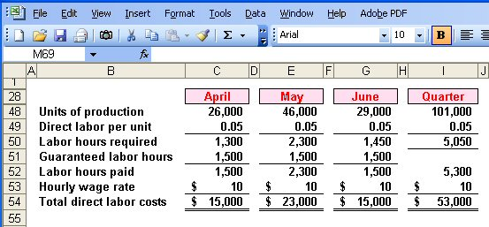

**LEARNING OBJECTIVE 6** Prepare a manufacturingoverhead budget.

***The Manufacturing Overhead Budget***

The **manufacturing overhead budget** provides a schedule of all costs of production other than direct materials and direct labor.

**Example:**

* At Royal, manufacturing overhead is applied to units of product on the basis of direct labor hours.
* The variable manufacturing overhead rate is $20 per direct labor hour.
* Fixed manufacturing overhead is $50,000 per month, which includes $20,000 of noncash costs (primarily depreciation of plant assets).
* Let’s prepare the manufacturing overhead budget.

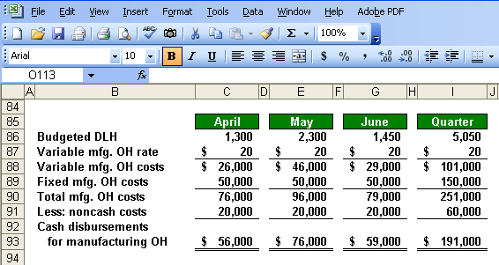

After completing Schedules 1–5, we had all of the data he needed to compute unit product costs. This computation is needed for two reasons: first, **to determine** **cost of goods sold on the budgeted income statement**; and second, **to know what amount to put on the balance sheet inventory account for unsold units**. The carrying cost of the unsold units is computed on the **ending finished goods inventory budget.**

**Ending Finished Goods Inventory Budget**



**LEARNING OBJECTIVE 7** Prepare a selling andadministrative expense budget.

***The Selling and Administrative Expense Budget***

The **selling and administrative expense budget** lists the budgeted expenses for areas other than manufacturing. In large organizations, this budget would be a compilation of many smaller, individual budgets submitted by department heads and other persons responsible for selling and administrative expenses. For example, the marketing manager in a large organization would submit a budget detailing the advertising expenses for each budget period.

**Example:**

* At Royal, the selling and administrative expense budget is divided into variable and fixed components.
* The variable selling and administrative expenses are $0.50 per unit sold.
* Fixed selling and administrative expenses are $70,000 per month.
* The fixed selling and administrative expenses include $10,000 in costs – primarily depreciation – that are not cash outflows of the current month.

Let’s prepare the company’s selling and administrative expense budget for Royal Company for the quarter ending June 30.

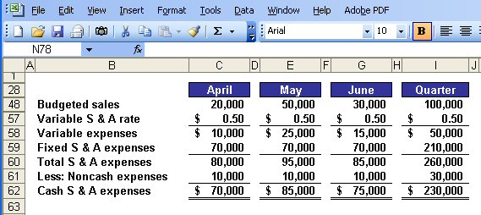

**LEARNING OBJECTIVE 8** Prepare a cash budget.

***The Cash Budget***

As illustrated in Exhibit 1–2, the cash budget pulls together much of the data developed in the preceding steps. It is a good idea to review Exhibit 1–2 to get the big picture firmly in mind before moving on.

The cash budget is divided into four sections:

1. Cash receipts section lists all cash inflows excluding cash received from financing;
2. Cash disbursements section consists of all cash payments excluding repayments of principal and interest;
3. Cash excess or deficiency section determines if the company will need to borrow money or if it will be able to repay funds previously borrowed; and
4. Financing section details the borrowings and repayments projected to take place during the budget period.

The receipts section consists of a listing of all of the cash inflows, except for financing, expected during the budget period. Generally, the major source of receipts will be from sales.

The disbursements section consists of all cash payments that are planned for the budget period. These payments will include raw materials purchases, direct labor payments, manufacturing overhead costs, and so on, as contained in their respective budgets. In addition, other cash disbursements such as equipment purchases and dividends are listed.

The cash excess or deficiency section is computed as follows:

Cash balance, beginning XXXX

Add receipts XXXX

Total cash available XXXX

Less disbursements XXXX

Excess (deficiency) of cash available over disbursements XXXX

If a cash deficiency exists during any budget period, the company will need to borrow funds. If there is a cash excess during any budget period, funds borrowed in previous periods can be repaid or the excess funds can be invested.

The financing section details the borrowings and repayments projected to take place during the budget period. It also lists interest payments that will be due on money borrowed.

Generally speaking, the cash budget should be broken down into time periods that are as short as feasible. Considerable fluctuations in cash balances may be hidden by looking at a longer time period. While a monthly cash budget is most common, some organizations budget cash on a weekly or even daily basis.

**Example:**

Assume the following additional information for Royal:

* + Maintains a 16% open line of credit for $75,000
  + Maintains a minimum cash balance of $30,000
  + Borrows on the first day of the month and repays loans on the last day of the month
  + Pays a cash dividend of $49,000 in April
  + Purchases $143,700 of equipment in May and $48,300 in June (both purchases paid in cash)
  + Has an April 1 cash balance of $40,000

Let’s prepare cash budget for Royal Company for the quarter ending June 30.

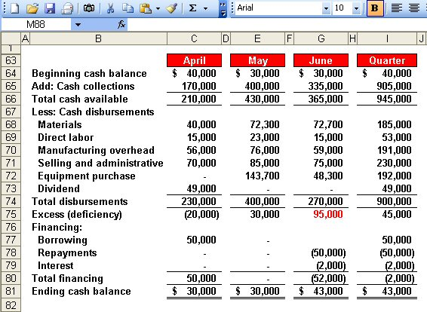

**LEARNING OBJECTIVE 9** Prepare a budgeted incomestatement.

**The Budgeted Income Statement**

A budgeted income statement can be prepared from the data developed in Schedules 1–8. *The budgeted income statement is one of the key schedules in the budget process.* It shows the company’s planned profit for the upcoming budget period, and it stands as a benchmark against which subsequent company performance can be measured.



**LEARNING OBJECTIVE 10** Prepare a budgeted balancesheet.

***The Budgeted Balance Sheet***

The budgeted balance sheet is developed by beginning with the balance sheet from the beginning of the budget period and adjusting it for the data contained in the various schedules.

**Example:**

Royal reported the following account balances prior to preparing its budgeted financial statements:

* + Land $50,000
  + Common stock $200,000
  + Retained earnings $146,150 (April 1)
  + Equipment $175,000

