**CHAPTER 3 FLEXIBLE BUDGETS, VARIANCES, AND MANAGEMENT CONTROL**

**Basic Concepts**

* Variance – difference between an actual and an expected (budgeted) amount
* Management by Exception – the practice of focusing attention on areas not operating as expected (budgeted)
* Static (Master) Budget – is based on the output planned at the start of the budget period

Static-Budget Variance (Level 0) – the difference between the actual result and the corresponding static budget amount **Favorable and Unfavorable Variances**

* Favorable variances arise when actual results exceed budgeted.
* Unfavorable variances arise when actual results fall below budgeted.
* Favorable (F) versus Unfavorable (U) Variances

**Profits Revenue Costs**

**Actual > Expected F F U**

**Actual < Expected U U F**

* Favorable Variance (F) – has the effect of increasing operating income relative to the budget amount
* Unfavorable Variance (U) – has the effect of decreasing operating income relative to the budget amount

**Types of Favorable and Unfavorable Variances**

* Favorable profit variances arise when actual profits exceed budgeted profits. Unfavorable profit variance occurs when actual profit falls below budgeted profit.
* Actual revenues that exceed budgeted revenues result in favorable revenue variances, and actual revenues that fall short of budgeted revenues result in unfavorable revenue variances.
* When actual costs exceed budgeted costs, we have unfavorable cost variances; when actual costs are less than budgeted costs, we have favorable cost variances.
* The favorable and unfavorable labels indicate only the directional relationships summarized in the charts – they do not indicate that the explanation for the variance is necessarily good or bad.
* To determine whether a variance is favorable or unfavorable, use logic rather than memorizing a formula.
* A price variance is favorable if the actual price is less than the standard.
* A quantity variance is favorable if the actual quantity used is less than the standard quantity allowed.

**Static and Flexible Budgets**

* A static budget is prepared for only one expected level of activity.
* A budget that adjusts to different levels of activity is a flexible budget (sometimes called a variable budget).
* Variances may start out “at the top” with a Level 0 analysis.
* This is the highest level of analysis, a super-macro view of operating results.
* The Level 0 analysis is nothing more than the difference between actual and static-budget operating income
* Further analysis decomposes (breaks down) the Level 0 analysis down into progressively smaller and smaller components
* Answers: “How much were we off?”
* Levels 1, 2, and 3 examine the Level 0 variance into progressively more-detailed levels of analysis
* Answers: “Where and why were we off?”

**Level 1 Analysis, Illustrated**

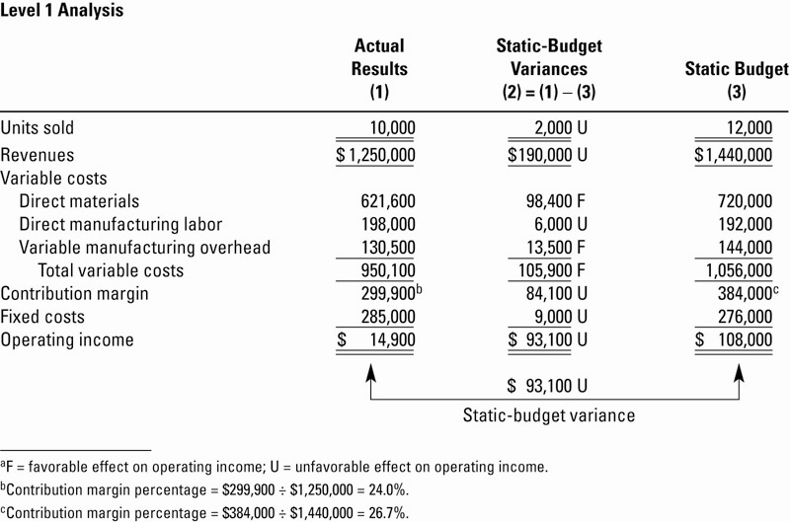

**Evaluation**

* Level 0 tells the user very little other than how much Contribution Margin was off from budget.
  + Level 0 answers the question: “How much were we off in total?”
* Level 1 gives the user a little more information: it shows which line-items led to the total Level 0 variance.
  + Level 1 answers the question: “Where were we off?”

**Flexible Budget**

* Flexible Budget – shifts budgeted revenues and costs up and down based actual operating results (activities)
* Represents a blending of actual activities and budgeted dollar amounts
* Will allow for preparation of Level 2 and 3 variances

**Level 2 Analysis, Illustrated**

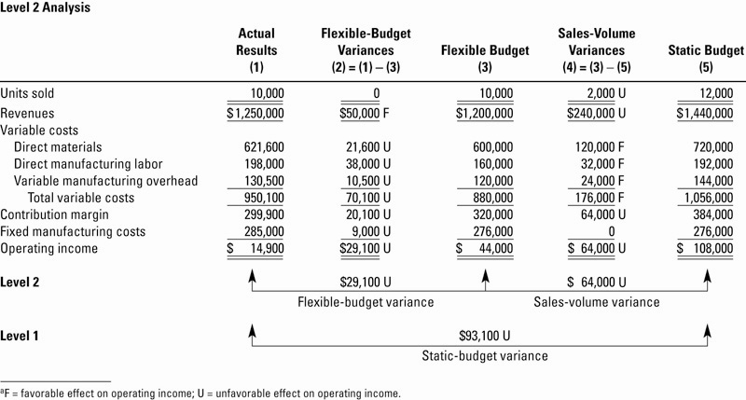

**Level 3 Analysis, Illustrated**

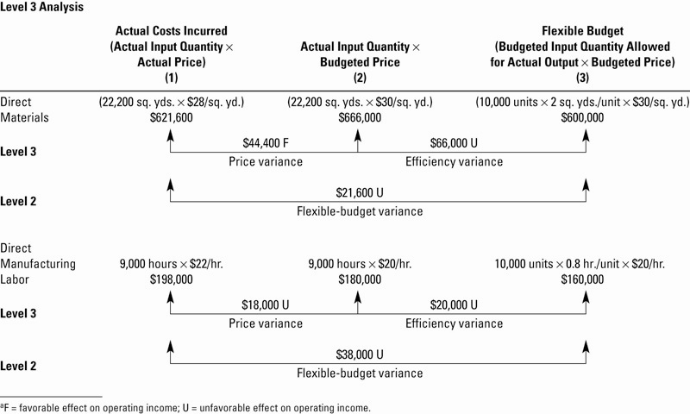

**Level 3 Variances**

* All Product Costs can have Level 3 Variances. Direct Materials and Direct Labor will be handled next. Overhead Variances are discussed in detail in a later chapter
* Both Direct Materials and Direct Labor have both Price and Efficiency Variances, and their formulae are the same

**Variance Summary**

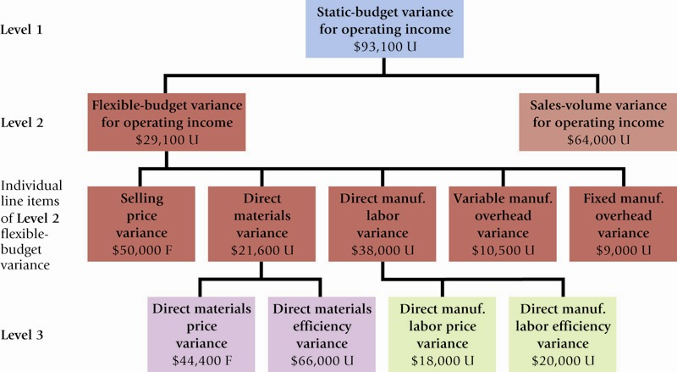

Answers the question: “Why were we off?”

**Level 3 Variances**

**Price Variance formula:**



**Efficiency Variance formula:**



**Planning and Overhead**

Variable overhead – as efficiently as possible, plan only essential activities

Fixed overhead – as efficiently as possible, plan only essential activities, especially because fixed costs are predetermined well before the budget period begins

**Standard Costing**

* Traces direct costs to output by multiplying the standard prices or rate by the standard quantities of inputs *allowed* for actual outputs produced
* Allocates overhead costs on the basis of the standard overhead-cost rates times the standard quantities of the allocation bases *allowed* for the actual outputs produced

**A Roadmap: Variable Overhead**



**A Roadmap: Fixed Overhead**



**Overhead Variances**

* Overhead is the most difficult cost to manage, and is the least understood.
* Overhead variances involve taking differences between equations as the analysis moves back and forth between actual results and budgeted amounts.

**Developing Budgeted Variable Overhead Cost Rates**

1. Choose the period to be used for the budget.
2. Select the cost-allocation bases to use in allocating variable overhead costs to output produced.
3. Identify the variable overhead costs associated with each cost-allocation base.
4. Compute the rate per unit of each cost-allocation base used to allocate variable overhead costs to output produced.

**The Details: Variable OH Variances**

* Variable overhead flexible-budget variance measures the difference between actual variable overhead costs incurred and flexible-budget variable overhead amounts.



* Variable overhead efficiency variance is the difference between actual quantity of the cost-allocation base used and budgeted quantity of the cost per unit of the cost-allocation base.



**Developing Budgeted Fixed Overhead Cost Rates**

1. Choose the period to be used for the budget.
2. Select the cost-allocation bases to use in allocating fixed overhead costs to output produced.
3. Identify the fixed overhead costs associated with each cost-allocation base.
4. Compute the rate per unit of each cost-allocation base used to allocate fixed overhead costs to output produced.

**The Details: Fixed OH Variances**

* Fixed overhead flexible-budget variance is the difference between actual fixed overhead costs and fixed overhead costs in the flexible budget.
* This is the same amount for the fixed overhead spending variance.



* Production-volume variance is the difference between budgeted fixed overhead and fixed overhead allocated on the basis of actual output produced.
* This variance is also known as the denominator-level variance or the output-level overhead variance.



* Interpretation of this variance is difficult due to the nature of the costs involved and how they are budgeted.
* Fixed costs are by definition somewhat inflexible. While market conditions may cause production to flex up or down, the associated fixed costs remain the same.
* Fixed costs may be set years in advance, and may be difficult to change quickly.
* *Contradiction*: Despite this, examination of the fixed overhead budget formulae reveals that it is budgeted similar to a *variable* cost.

**Variable Overhead Variance Analysis Illustrated**

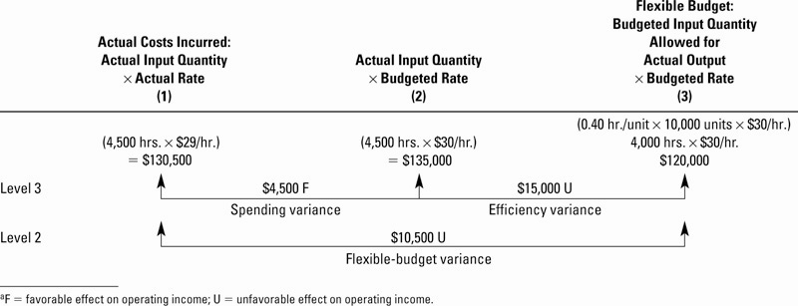

**Fixed Overhead Variance Analysis Illustrated**

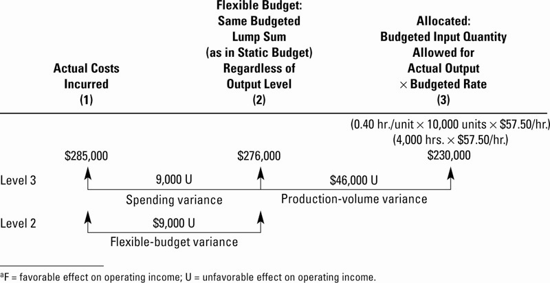

**Production-Volume Variance**

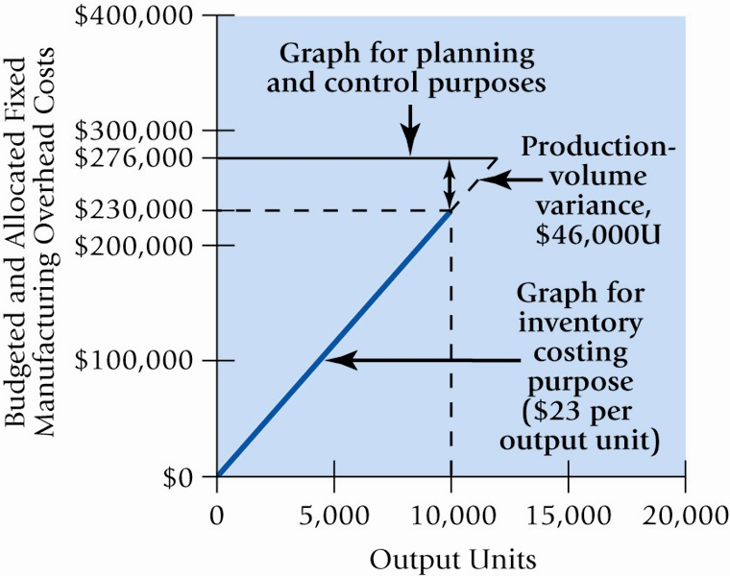

**Integrated Variance Analysis Illustrated**

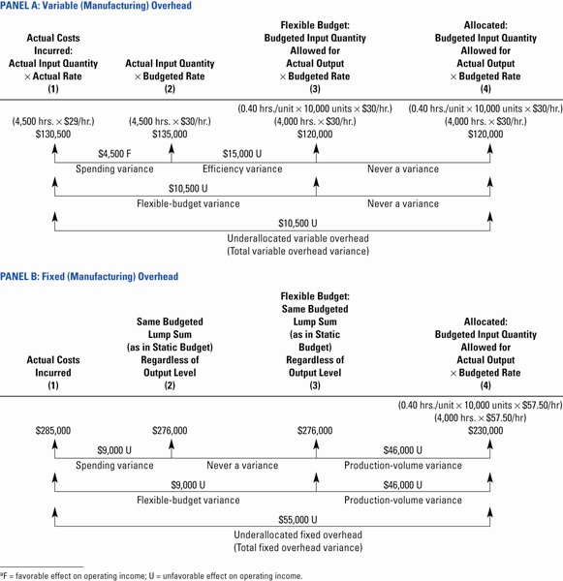

Master budgets are based on estimated volumes of production and sales. What if actual volume differs from the budgeted amount? This is called a “static” budget. A flexible budget is one which is designed to change as volume of levels change. It is a valuable management tool for planning and control.

A flexible budget shows budgeted sales and revenues at various levels of activity. It is based on the assumption that cost behavior is either fixed or variable.

There are two static budget variances.

1. The sales volume variance–number of units actually sold differs from static budget units

2. The flexible budget variance–entity actually earned more or less revenue than expected for actual level of output

A variance is labeled as favorable if it increases income. A variance is labeled as unfavorable if it decreases income.

The sales volume variance is the difference between the *static* (master) budget and the *flexible* budget (for the actual number of outputs). The variance arises *only* because the number of units actually sold differs from the volume originally planned for in the master budget.

As the name suggests, the flexible budget variance is the difference between the *flexible* budget and the *actual results.*