CHAPTER 3 SYSTEM DESIGN: JOB ORDER COSTING
CHAPTER LEARNING OBJECTIVES
After completing this chapter, you should be able to:

LO 1: Describe the key differences between job order costing and process costing.
LO 2: Describe the source documents used to track direct materials and direct labor costs to the job cost sheet.
LO 3: Calculate a predetermined overhead rate and use it to apply manufacturing overhead cost to jobs.
LO 4: Describe how costs flow through the accounting system in job order costing.
LO 5: Calculate and dispose of overapplied or underapplied manufacturing overhead.
LO 6: Calculate the cost of goods manufactured and cost of goods sold.

CHAPTER CONTENTS

Job order versus process costing
- Process costing
- Job order costing
Assigning manufacturing costs to jobs
- Manufacturing cost categories
- Materials requisition form
- Direct labor time tickets
- Job cost sheet
- Predetermined overhead rates
Recording the flow of costs in job order costing
- Recording the purchase and issue of materials
- Recording labor costs
- Recording actual manufacturing overhead
- Recording applied manufacturing overhead
- Transferring costs to finished goods inventory and cost of goods sold
- Recording nonmanufacturing costs
Overapplied or underapplied manufacturing overhead
- Calculating overapplied and underapplied manufacturing overhead
- Disposing of overapplied or underapplied manufacturing overhead
- Preparing the cost of goods manufactured report

JOB ORDER VERSUS PROCESS COSTING

Job-order costing and process costing are two common methods for determining unit product costs. Job-order costing is used when many different jobs or products are worked on each period. Examples of industries that use job-order costing include furniture manufacturing, special-order printing, shipbuilding, and many types of service organizations.

By contrast, process costing is used most commonly in industries that convert raw materials into homogeneous (i.e., uniform) products, such as bricks, soda, or paper, on a continuous basis. Process costing is used by companies that make standardized or homogeneous products or services, such as Coca-Cola beverages, Kraft macaroni and cheese, and Exxon petroleum products. In addition, process costing is sometimes used in companies with assembly operations. A form of process costing may also be used in utilities that produce gas, water, and electricity. These and many other common products are produced in a continuous manufacturing process in which raw materials are put through a standardized production process so that each unit of the final product comes out identical to the next. Because each unit is the same, there is no need to track the cost of each unit individually. Instead, process costing breaks the production process down into its basic steps, or processes, and then averages the total cost of the process over the number of units produced. The basic process costing formula is:

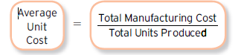

Although this formula makes process costing sound simple, a few questions complicate its use in the real world. For example, how much cost should Coca-Cola assign to soft drinks that are still in process at the end of the month—that is, when all of the ingredients have been added but the bottling process is not yet complete? These issues will be discussed in more detail in the next chapter, which focuses specifically on process costing.

Comparison of Job-Order and Process Costing

In some ways process costing is very similar to job-order costing, and in some ways it is very different. In this section, we focus on these similarities and differences to provide a foundation for the detailed discussion of job order costing in this chapter and process costing in the next chapter.

Similarities between Job-Order and Process Costing

The similarities between job-order and process costing can be summarized as follows:

- Both systems have the same basic purposes—to assign material, labor, and manufacturing overhead costs to products and to provide a mechanism for computing unit product costs.
- Both systems use the same basic manufacturing accounts, including Manufacturing Overhead, Raw Materials, Work in Process, and Finished Goods.
- The flow of costs through the manufacturing accounts is basically the same in both systems.

Differences between Job-Order and Process Costing

There are three differences between job-order and process costing. First, process costing is used when a company produces a continuous flow of units that are indistinguishable from one another/homogeneous (similar) products or services. Job-order costing is used when a company produces many different jobs that have unique production requirements/ heterogeneous (different) products or services. Second, under process costing, it makes no sense to try to identify materials, labor, and overhead costs with a particular customer order (as with job-order costing) because each order is just one of many that are filled from a continuous flow of virtually identical units from the production line. Accordingly, process costing accumulates costs by department (rather than by order) and assigns these costs uniformly to all units that pass through the department during a period. Job cost sheets (which are used for job-order costing) are not used to accumulate costs. Third, process costing systems compute unit costs by department. This differs from job-order costing where unit costs are computed by job on the job cost sheet. Exhibit 3 – 1 summarizes the differences just described.

Exhibit 3 – 1Differences between Job Order Costing versus Process Costing

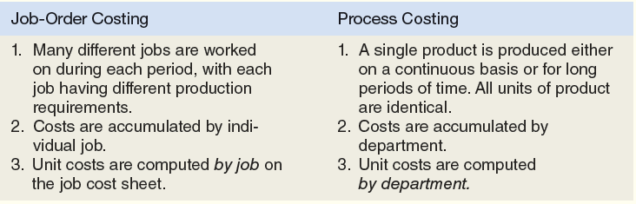

JOB ORDER COSTING

Job order costing is used in companies that offer customized or unique products or services. Unlike process costing, in which each unit is identical to the next, job order costing is used for situations in which each unit or customer tends to be very different from the next. Examples include:

Job order costing is also common in service industries that serve clients or customers with unique needs. For example, the accounting firm Ernst and Young, LLP tracks the billable hours spent on each individual client’s account. Law firms, architectural firms, and consulting firms also track the co sts of serving individual clients.

ASSIGNING MANUFACTURING COSTS TO JOBS

In this section, we illustrate how to assign manufacturing costs to unique products, called jobs, using job order costing. Although job order cost systems are commonly used by service firms, accounting for manufacturing costs is more complicated because a physical product can be stored as inventory, while services cannot. GAAP requires that all manufacturing costs be traced to the product, which means that manufacturing costs should be counted as inventory (an asset) until the product is sold.

MANUFACTURING COST CATEGORIES

As you learned in Chapter 2, manufacturing costs are divided into three categories:

- Direct materials are the primary material inputs that can be directly and conveniently traced to each job. Examples of direct materials used in building a home include concrete, piping, lumber, drywall, fixtures, and appliances.
- Direct labor is the hands-on work that goes into producing a product or service. Examples of direct labor used in building a home include the work of pouring the foundation, framing the home, and installing the plumbing.
- Manufacturing overhead includes all other costs of producing a product that cannot be directly or conveniently traced to a specific job. Examples of the manufacturing overhead required to build (not sell) a home include the costs of site supervision, construction insurance, depreciation on construction equipment, and indirect materials (nails, screws, and so on).

In a job order cost system, all of these manufacturing costs are recorded on a document called the job cost sheet, which provides a detailed record of the cost incurred to complete a specific job. Refer to Exhibit 3 - 2 for an illustration of how the three types of manufacturing costs are assigned in a job order cost system.

- In job order costing, each unique product or customer order is called a job. The cost of each unique job is recorded on a document called a job cost sheet.

Exhibit 3 - 2 Assignment of Manufacturing Costs to Jobs

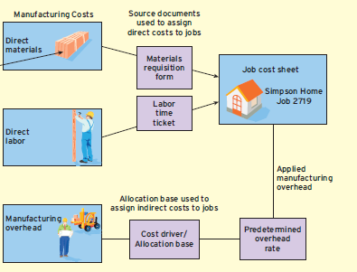

The most important thing to notice in Exhibit 3 - 2 is that direct materials and direct labor costs are assigned to jobs differently than manufacturing overhead costs. For direct costs, all that is needed to keep track of the costs of specific jobs is a set of records called source documents. In a manual (paper-based) accounting system, a source document is a hard copy document similar to the receipt you get when you buy something at a store. But more companies are moving to paperless systems that record all of the information electronically and track it using technology such as bar codes, computer scanning devices, and other technologies. For simplicity, we illustrate the “old-fashioned” method using paper documents to trace direct materials and direct labor costs to specific jobs.

In contrast to direct materials and direct labor, which can be traced directly to jobs using source documents, manufacturing overhead is made up of costs that cannot be directly or conveniently traced to specific jobs. To assign these indirect costs to jobs, accountants must use a predetermined overhead rate that is based on some secondary allocation measure, or cost driver.
Let’s start by assigning the direct cost to specific jobs using materials requisition forms and direct labor time tickets.

MATERIALS REQUISITION FORM

Before materials can be used on a job, a materials requisition form —a form that lists the quantity and cost of the direct materials used on a specific job—must be filled out. This form is used to control the physical flow of materials out of inventory and into production. It also provides the information needed to record the cost of raw materials in the accounting system.

As an example, assume that Toll Brothers is getting ready to frame the interior and exterior walls of the Simpson family’s new 2,500-square-foot custom home. The Simpson home has been numbered Job 2719. Before the lumber can be delivered to the job site, a materials requisition form like the one that follows must be completed.
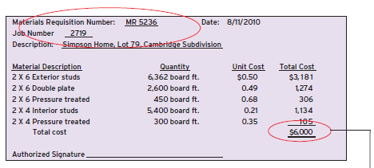
This document provides the details needed to record direct material costs in a job order cost system.

- Source documents always include identification numbers that can be used to cross reference the documents in the accounting records. Here, the total cost on this materials requisition form ($6,000) will be posted to Job 2719.

DIRECT LABOR TIME TICKETS
A direct labor time ticket is a source document that shows how much time a worker spent on various jobs each week, as in the following illustration:
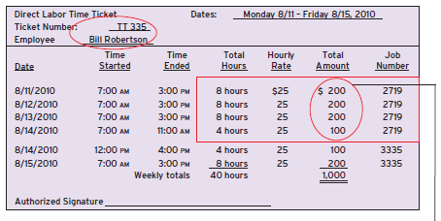
Like the materials requisition form, a direct labor time ticket is used to record direct labor costs in a job order cost system.

- This time ticket shows that Bill Robertson spent 28 hours on Job 2719. Because Bill makes $25 per hour, accountants would charge a total of $700 (28 x $25) to Job 2719. The rest of Bill’s time would be charged to Job 3335.

JOB COST SHEET

The job cost sheet is a document that summarizes all of the costs incurred on a specific job. For example, the costs from the preceding materials requisition form and labor time ticket would be posted to the job cost sheet for the Simpson home (Job 2719) as follows:

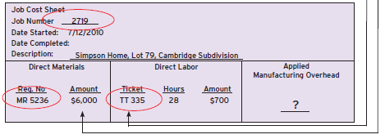
Notice that this job cost sheet shows the actual amount of direct materials and direct labor incurred on Job 2719. But we have not yet recorded the manufacturing overhead or indirect costs of building the home. The method for assigning indirect costs to jobs is described next.

PREDETERMINED OVERHEAD RATES

The third type of cost that must be recorded is manufacturing overhead. Unlike direct materials and direct labor costs, which can be traced to individual jobs using source documents, manufacturing overhead costs cannot be directly traced to specific jobs. The production supervisor’s salary, for example, and depreciation on construction equipment are common costs that relate to multiple jobs. Theoretically, some indirect costs such as indirect materials (screws, nails, and so on) could be traced to individual jobs, but doing so is probably not worth the effort.

- Manufacturing overhead costs are more difficult to assign than direct materials and direct labor costs, which can be traced directly to specific jobs. By definition, manufacturing overhead costs are not traceable to specific jobs, so they must be allocated or assigned to jobs using some other observable measure.

As a simple example, think about the last time you had your car repaired. The cost of the repair probably included parts and labor plus some additional amount to cover the indirect costs of operating the garage, such as oil, lubricants, and machines. How does the owner or manager of the garage decide how much to charge for those indirect costs? They probably add some percentage to the direct labor cost, which assumes that more time spent on a repair will result in more indirect costs as well. This rate or percentage must be calculated in advance so that the shop can provide a bid or estimate for customers who bring their car in for repair.

In our home-building example, indirect manufacturing overhead costs must be assigned to specific jobs using a secondary measure called an allocation base. Ideally, the allocation base should explain why the cost is incurred. An allocation base that is causally related to cost incurrence is sometimes called a cost driver. For example, some manufacturing overhead costs, such as employee taxes and site supervision, are driven by the number of direct labor hours worked. Other costs such as machine maintenance and fuel are driven by the amount of time that construction equipment is used. The cost of indirect materials such as glue, sandpaper, and insulation is driven by the square footage of the home under construction.

For simplicity, we use a single allocation base to assign manufacturing overhead costs to jobs. Because home building is a labor-intensive business, we assume that Toll Brothers uses direct labor hours as the allocation base for assigning manufacturing overhead costs to jobs.

Before we can assign manufacturing overhead costs to jobs, we must first calculate a predetermined overhead rate using our chosen allocation base. The predetermined overhead rate is calculated as follows:

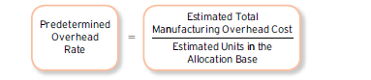
This overhead rate is calculated for an entire accounting period (typically a year) and is based on estimated rather than actual values. We often do not know the actual manufacturing overhead cost until after the month, quarter, or year has ended. Thus, accountants must use their best estimate of the coming period’s manufacturing overhead based on past experience and any expectations they have about how the costs might change in the future.

- When you are asked to calculate a predetermined overhead rate, remember that it should be based on estimated rather than actual numbers. This rate is set in advance before the actual numbers are known.

Assume Toll Brothers estimates the total manufacturing overhead cost for the upcoming year to be $750,000 and total direct labor hours to be 10,000. Based on these estimates, the predetermined overhead rate is calculated as follows:

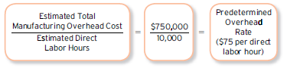
This rate suggests that the company needs to assign $75 in manufacturing overhead cost for each direct labor hour worked. This is not the cost of the direct labor itself, but rather all of the indirect costs of building a home such as indirect materials, depreciation on construction equipment, supervisors’ salaries, and insurance.

Once the predetermined overhead rate is established, managers can use it to determine how much overhead should be added to each job. They calculate the applied manufacturing overhead by multiplying the predetermined overhead rate by the actual value of the allocation base used on the job, as follows:

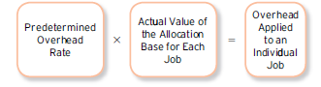

- Notice that the overhead cost applied on the job cost sheet is based on the predetermined (estimated) overhead rate multiplied by the actual number of direct labor hours worked on that job.

Assume that during the first week of construction, the Simpson home (Job 2719) required a total of 300 direct labor hours. Because the predetermined overhead rate is $75 per direct labor hour, the manufacturing overhead applied to the job is $22,500, calculated as follows:

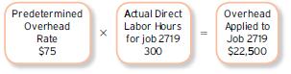

Accountants can apply manufacturing overhead costs as they record direct labor hours (based on the actual number of hours worked during a given week), or they can wait until the job is completed and apply all of the manufacturing overhead at once (based on the total direct labor hours worked on the job). If some jobs are still in process at the end of an accounting period, however, accountants must make sure that all cost records are up to date by applying overhead to all jobs in process at the end of the period. Assume the job cost sheet for the Simpson home at the end of the first week is as follows:

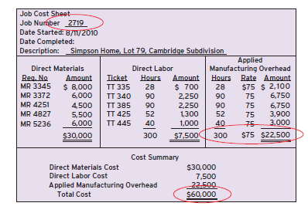
Notice that manufacturing overhead was applied to the job cost sheet based on the predetermined (estimated) overhead rate of $75 per direct labor hour. Because this rate was based on estimated data, applied manufacturing overhead is unlikely to be exactly the same as the actual manufacturing overhead cost incurred. You will see how to record actual manufacturing overhead costs and how to account for any difference between actual and applied manufacturing overhead later in this chapter.

RECORDING THE FLOW OF COSTS IN JOB ORDER COSTING

This section describes how manufacturing costs are recorded in a job order cost system. Although we do not show the detailed journal entries, we use T-accounts to show how the manufacturing costs flow through the various inventory accounts before eventually being recognized as Cost of Goods Sold.
The three inventory accounts that are used to record manufacturing costs follow:
- Raw Materials Inventory represents the cost of materials purchased from suppliers but not yet used in production. This account includes all raw materials, including the direct materials that will be traced to specific jobs (lumber, piping) and the indirect materials that cannot be traced to specific jobs (screws, nails, and so on).
- Work in Process Inventory represents the total cost of jobs that are in process. Any cost that is added to the Work in Process Inventory account must also be recorded on the individual job cost sheet. Thus, the total cost of all jobs in process should equal the balance in Work in Process Inventory.
- Finished Goods Inventory represents the cost of jobs that have been completed but not yet sold. The cost of a completed job remains in the Finished Goods Inventory account until it is sold.

When a job is sold, its total cost is transferred out of Finished Goods Inventory and into Cost of Goods Sold. See Exhibit 3 - 3 for an illustration of the flow of manufacturing costs through these inventory accounts before being recognized as Cost of Goods Sold.

- Notice that the manufacturing costs appear in inventory accounts while the product is being made. They don’t appear on the Income Statement until the product is sold.

Exhibit 3 - 3 Flows of Manufacturing Costs through the Inventory Accounts

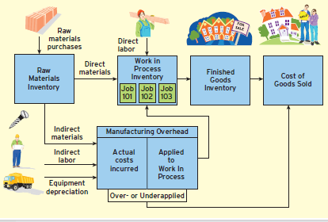

When materials are purchased, the cost is initially recorded in Raw Materials Inventory. As materials are used, the cost is transferred to either Work in Process Inventory (for direct materials) or to Manufacturing Overhead (for indirect materials). All costs added to the Work in Process Inventory account must be assigned to a specific job (and recorded on the individual job cost sheet). Notice that only direct materials and direct labor costs are recorded directly in the Work in Process Inventory account. All indirect or manufacturing overhead costs flow through the Manufacturing Overhead account.

The Manufacturing Overhead account is a temporary holding account used to record actual and applied manufacturing overhead costs. Actual manufacturing overhead costs are accumulated on the debit (left-hand) side of the Manufacturing Overhead account. The credit (right-hand) side of the account shows the manufacturing overhead that is applied to specific jobs based on the predetermined overhead rate described in the previous section.

As jobs are in process, the Work in Process Inventory account accumulates the actual direct materials, actual direct labor, and applied manufacturing overhead cost of each job. When a job is completed, its total manufacturing cost is transferred out of Work in Process Inventory and into the Finished Goods Inventory account. When the job is sold, these costs are transferred to the Cost of Goods Sold account where they will be matched against Sales Revenue on the income statement.

At the end of the reporting period, any difference between actual and applied manufacturing overhead (represented by the balance in the Manufacturing Overhead account) must be accounted for. Companies can either adjust Cost of Goods Sold directly, as shown in Exhibit 3 - 3, or adjust Work in Process Inventory, Finished Goods Inventory, and Cost of Goods Sold. Later in the chapter, we illustrate the simpler of these two methods.

The next section provides an example to illustrate the flow of manufacturing costs in job order costing. The detailed journal entries for each transaction are shown in the Supplement to this chapter. For simplicity, we assume that none of the accounts had a beginning balance and that the company worked on only two jobs during the period.

RECORDING THE PURCHASE AND ISSUE OF MATERIALS

When materials are purchased, they are initially recorded in Raw Materials Inventory. This account shows the cost of all materials purchased but not yet issued into production, and includes both direct and indirect material purchases.

Before materials can be issued out of Raw Materials Inventory, managers must fill out a materials requisition form that indicates which job or jobs the material will be used for. The direct materials are recorded on the specific job cost sheet and in Work in Process Inventory. Indirect materials, or materials that cannot be traced to a specific job, are not recorded directly to the job cost sheet or Work in Process Inventory. Rather, these indirect costs are accumulated in the Manufacturing Overhead account and will be applied to the product using the predetermined overhead rate.
As an example, assume that $150,000 worth of materials is withdrawn from Raw Materials Inventory for the following uses:

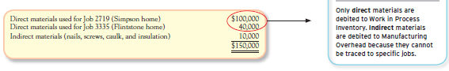

Exhibit 3 – 4 shows how these direct and indirect materials would be recorded in the Raw Materials Inventory, Work in Process Inventory, and Manufacturing Overhead accounts.

Exhibit 3 – 4 Recording Direct and Indirect Materials Costs

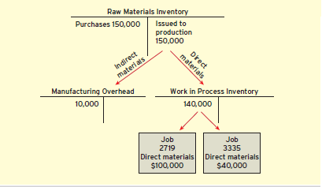

Notice that $140,000 in direct materials is added directly to Work in Process Inventory with $100,000 being recorded on Job 2719 and $40,000 recorded on Job 3335. These job cost sheets serve as a subsidiary ledger to the overall Work in Process Inventory account. Thus, the total cost of all jobs in process should equal the overall balance in the Work in Process Inventory account.
The $10,000 cost of indirect materials (nails, screws, caulk, and insulation) is not traced to the individual jobs but is accumulated on the debit (left) side of the Manufacturing Overhead account.

RECORDING LABOR COSTS

Labor costs are recorded in much the same way as direct materials: based on the direct labor time tickets that show how much time was spent on each job. If the labor can be traced to a specific job, the cost is added to the job cost sheet and the Work in Process Inventory account. If it is not traceable to a specific job, the cost is considered indirect labor and is debited to the Manufacturing Overhead account.

Assume Toll Brothers recorded the following labor costs:

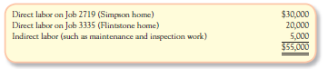

See Exhibit 3 – 5 for a summary of how these costs would appear in the Manufacturing Overhead and Work in Process Inventory accounts.

Exhibit 3 – 5 Recording Direct and Indirect Labor Costs

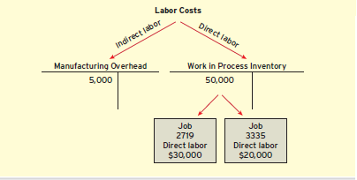

RECORDING ACTUAL MANUFACTURING OVERHEAD

Actual manufacturing costs include all of the indirect manufacturing costs, or those that cannot be traced to specific units or jobs. These costs are not recorded directly in the Work in Process Inventory account. Instead, these indirect costs are accumulated in the Manufacturing Overhead account.

We have already recorded the indirect materials and indirect labor costs in the Manufacturing Overhead account. Assume Toll Brothers recorded the following additional manufacturing overhead costs during the month:
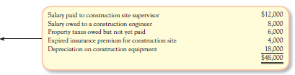
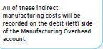
These actual manufacturing overhead costs are added to the Manufacturing Overhead account (see Exhibit 3 – 6). Actual manufacturing overhead costs are always shown on the left-hand (debit) side of the Manufacturing Overhead account. Next we show how these indirect costs are applied to the Work in Process Inventory account using the predetermined overhead rate.

RECORDING APPLIED MANUFACTURING OVERHEAD

Remember that manufacturing overhead costs are applied to jobs based on the predetermined overhead rate that was estimated at the beginning of the accounting period. As jobs are worked on during the period, we determine the amount of manufacturing overhead cost to apply to specific jobs by multiplying the predetermined overhead rate by the actual number of direct labor hours worked.

In our home-building example, we estimated the manufacturing overhead rate to be $75 per direct labor hour. This rate is not the cost of the direct labor itself, but rather the amount of manufacturing overhead cost that needs to be added for each direct labor hour worked to cover the indirect costs of building the home (equipment depreciation, insurance, supervision, etc.).

Assume Toll Brothers’ labor time tickets for the month revealed the following:

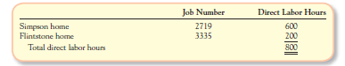

Because the overhead rate is $75 per direct labor hour, we need to apply a total of $60,000 (800 hours x $75 per direct labor hour) in manufacturing overhead costs to the Work in Process Inventory account. This amount is taken out of the Manufacturing Overhead account (with a credit) and added to the Work in Process Inventory account (with a debit), as shown in Exhibit 3 – 6.

Exhibit 3 – 6 Recording Actual and Applied Manufacturing Overhead Costs

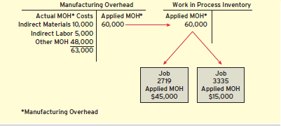

Anytime that we add cost to the Work in Process Inventory account, we must also update the individual job cost sheets. For the Simpson home, we would apply $45,000 (600 hours x $75 per hour) to Job 2719. For the Flintstone home, we would apply $15,000 (200 hours x $75) to Job 3335.

Notice that the $60,000 applied to Work in Process Inventory is not equal to the actual manufacturing overhead cost incurred of $63,000 ($10,000 _ $5,000 _ $48,000). We will discuss how to handle the difference between actual and applied manufacturing overhead costs later in this chapter.

TRANSFERRING COSTS TO FINISHED GOODS INVENTORY AND COST OF GOODS SOLD

When a job is finally completed, the job cost sheet must be updated to reflect all direct materials, direct labor, and applied overhead costs that should be charged to the job. Once all manufacturing costs for the Simpson home have been updated, the summary section of the final job cost sheet appears as follows:

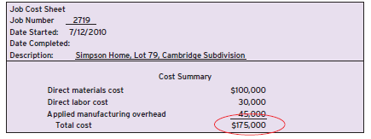

The total cost to complete the job is referred to as the cost of goods manufactured or cost of goods completed. This is the total cost that must be transferred from the Work in Process Inventory account to the Finished Goods Inventory account. Because this home was built for a specific customer, the new owners should take ownership shortly after construction is complete (and it passes the owners’ inspection). Once the sale is final, accountants will move the total cost of the job from the Finished Goods Inventory account to Cost of Goods Sold, as shown in Exhibit 3 – 7.

Exhibit 3 – 7 Recording Finished Goods Inventory and Cost of Goods Sold

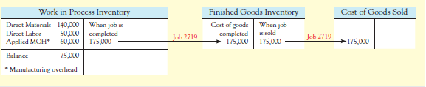

Cost of Goods Sold of $175,000 includes all manufacturing costs of building the Simpson home, including actual direct materials, actual direct labor, and applied manufacturing overhead. This amount will be matched against sales revenue on the income statement. For example, if the Simpsons agreed to pay $275,000 for their home, the company would report $275,000 in Sales Revenue and $175,000 in Cost of Goods Sold, for $100,000 in gross profit. However, we still need to account for two factors.

First, the $175,000 in Cost of Goods Sold includes only the manufacturing costs. We still need to account for the nonmanufacturing costs. Recall that nonmanufacturing costs are always expensed as they are incurred. Period expenses do not flow through the Work in Process, Finished Goods Inventory, and Cost of Goods Sold accounts, but rather are subtracted after gross profit on the income statement.

Second, we need to adjust for any difference in actual and applied manufacturing overhead. This is typically done at the end of the fiscal year, because any difference in actual or applied often balances out over time.

RECORDING NONMANUFACTURING COSTS

In addition to the manufacturing costs just described, companies incur many other nonmanufacturing costs to market the products and run the businesses. Nonmanufacturing costs are treated differently than manufacturing costs. Instead of being treated as part of the product cost (included in inventory and eventually cost of goods sold), nonmanufacturing costs are expensed during the period in which they are incurred.

Assume Toll Brothers incurred the following nonmanufacturing expenses last month:

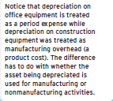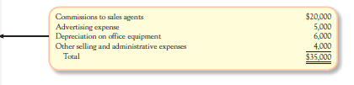

These nonmanufacturing costs would be recorded in individual expense accounts, including Commissions Expense, Advertising Expense, Depreciation Expense, and Miscellaneous Expenses. The total selling and administrative expense of $35,000 would be subtracted from gross margin on the income statement.

OVERAPPLIED OR UNDERAPPLIED MANUFACTURING OVERHEAD

CALCULATING OVERAPPLIED AND UNDERAPPLIED MANUFACTURING OVERHEAD

Because applied manufacturing overhead is based on a predetermined overhead rate that is estimated before the accounting period begins, it will probably differ from the actual manufacturing overhead cost incurred during the period. The difference between actual and applied overhead is called overapplied or underapplied overhead. Overhead cost is overapplied if the amount applied is more than the actual overhead cost. It is underapplied if the amount applied is less than the actual cost.

After recording the actual and applied manufacturing overhead in our home-building example, the Manufacturing Overhead account would appear as follows:

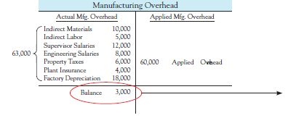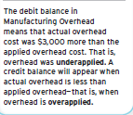

Notice that actual overhead cost was $63,000, but applied overhead was only $60,000, resulting in $3,000 of underapplied overhead. We discuss how to dispose of this overhead balance next.

DISPOSING OF OVERAPPLIED OR UNDERAPPLIED MANUFACTURING OVERHEAD

The most common method for disposing of the balance in Manufacturing Overhead is to make a direct adjustment to Cost of Goods Sold. Doing so makes sense as long as most of the jobs worked on during the period were completed and sold. However, if a significant amount of cost remains in Work in Process Inventory or Finished Goods Inventory, then part of the over- or underapplied manufacturing overhead technically should be adjusted to those accounts.

In this example, the company worked on only two jobs. One was completed and sold, but the other is still in process at the end of the accounting period. In reality, most companies complete and sell more than two jobs during the accounting period. Thus, we demonstrate the simplest and most common method of transferring the balance in the Manufacturing Overhead account directly to Cost of Goods Sold.

To eliminate the $3,000 debit balance in the Manufacturing Overhead account, we need to credit the Manufacturing Overhead account and debit the Cost of Goods Sold account. Debiting Cost of Goods Sold increases it by $3,000. Increasing Cost of Goods Sold makes sense in this case because manufacturing overhead was underapplied. In other words, we did not apply enough cost to the jobs that were completed and eventually sold.

If Manufacturing Overhead had been overapplied (with a credit balance), we would have debited the Manufacturing Overhead account (to remove the credit balance) and credited Cost of Goods Sold. Crediting Cost of Goods Sold decreases it to reflect the fact that actual manufacturing overhead was less than applied overhead—that is, overhead was overapplied. The effect of disposing of the Manufacturing Overhead balance to the Cost of Goods Sold account is as follows:

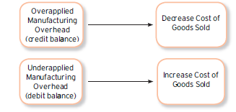

PREPARING THE COST OF GOODS MANUFACTURED REPORT

The total cost that is transferred out of Work in Process Inventory and into Finished Goods Inventory is called the cost of goods manufactured or cost of goods completed. It represents the total cost of all jobs completed during the period.

The cost of goods manufactured report summarizes the flow of manufacturing costs through Raw Materials Inventory, Work in Process Inventory, and into Finished Goods Inventory. In addition to documenting the amount of direct materials, direct labor, and manufacturing overhead costs applied to Work in Process Inventory, it makes adjustments for the beginning and ending values of the inventory accounts. See Exhibit 3 – 8 for the final balance in each of the accounts after all of the previous transactions have been posted.

Recall that the company worked on only two jobs during the period. Because only one job (3335) is still in process at the end of the accounting period, the balance in the Work in Process Inventory account equals the total cost recorded on that job ($75,000). The ending balance in Finished Goods Inventory is zero because the only job completed during the period was also sold. The ending balance in Cost of Goods Sold represents the cost of Job 2719 ($175,000) plus the adjustment for underapplied manufacturing overhead ($3,000).

Exhibit 3 – 8 Summary of Recorded Manufacturing and Nonmanufacturing Costs

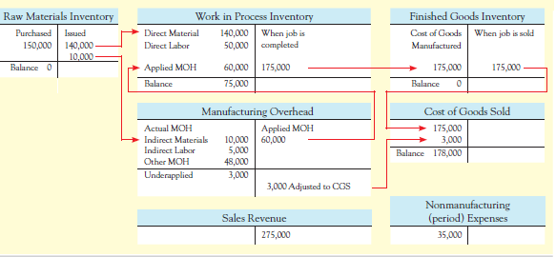

Using the T-accounts shown in Exhibit 3 – 8, we can prepare a cost of goods manufactured report as follows.
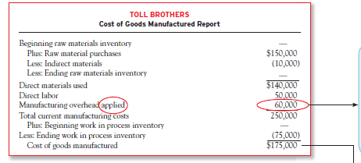
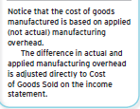

The cost of goods manufactured statement feeds into the Cost of Goods Sold section of the income statement as shown:

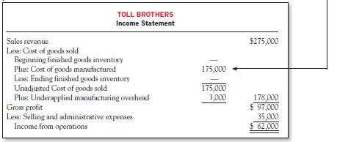

Notice that gross profit is $97,000, which is $3,000 less than the gross profit we initially computed for the sale of the Simpson home. The reason is that we adjusted the underapplied manufacturing overhead directly to Cost of Goods Sold and the Simpson home was the only job sold during the period.

In reality, most companies have many more jobs (or clients) that are completed and sold during a given period. This example was designed, however, to illustrate a very simple case in which only two jobs were worked on during the period. One job was still in process at the end of the period, and the other was completed and sold.

JOURNAL ENTRIES FOR JOB ORDER COSTING

This supplement illustrates the journal entries used to record the flow of costs in job order costing. For the sake of simplicity, we assume that none of the accounts had a beginning balance and that the company worked on only two jobs during the period.
Recording the Purchase and Issue of Materials

When materials are purchased, the total cost is debited to the Raw Materials Inventory account. The credit should be to Cash or Accounts Payable, depending on the form of payment. Assume that Toll Brothers purchased $150,000 in raw materials on account. The journal entry to record the purchase of raw materials follows:

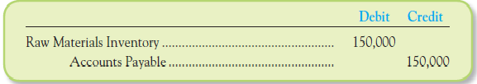

When materials are placed into production, the cost is debited to either Work in Process Inventory (for direct materials) or Manufacturing Overhead (for indirect materials). The credit entry should be to Raw Materials Inventory.

Assume that $150,000 worth of materials is withdrawn from inventory for the following uses:
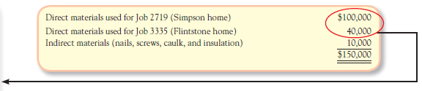

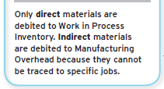
The entry to record the issuance of direct and indirect materials follows:

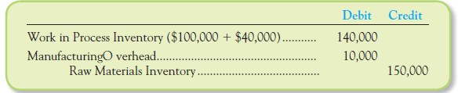

Recording Labor Costs

Direct labor costs are debited to Work in Process Inventory. Indirect labor costs are debited to Manufacturing Overhead. The corresponding credit should be to Wages Payable.

Assume Toll Brothers recorded the following information:
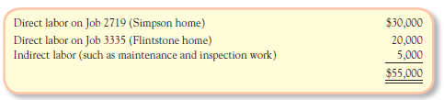

The journal entry to record the direct and indirect labor follows:
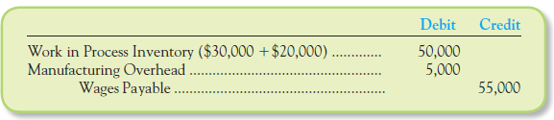

Recording Actual Manufacturing Overhead

Actual manufacturing overhead costs are debited to the Manufacturing Overhead account. The credit is to Cash, Accounts Payable, Prepaid Assets, and/or Accumulated Depreciation, depending on the nature of the transaction.

Assume Toll Brothers recorded the following actual manufacturing overhead costs during the month:
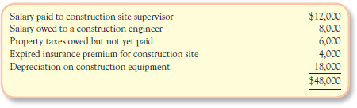
The combined journal entry to record these actual manufacturing overhead costs is:

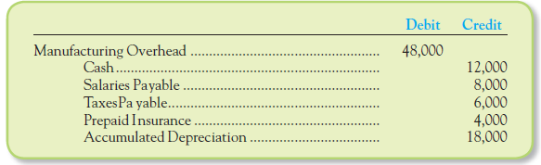

Recording Applied Manufacturing Overhead

Manufacturing overhead costs are applied to jobs by debiting the Work in Process Inventory account and crediting the Manufacturing Overhead account. Previously, we estimated the manufacturing overhead rate to be $75 per direct labor hour. Assume Toll Brothers labor time tickets for the month revealed the following:

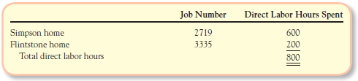
Because the overhead rate is $75 per direct labor hour, we need to apply a total of $60,000 (800 hours x $75 per direct labor hour) in manufacturing overhead costs to the Work in Process Inventory account. A corresponding credit should be made to the Manufacturing Overhead account, as shown in the following entry:
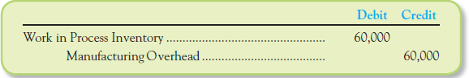

Transferring Costs to Finished Goods Inventory and Cost of Goods Sold

When a job is completed, the total cost of the job must be transferred from the Work in Process Inventory account to the Finished Goods Inventory account. For example, when Toll Brothers completes the Simpsons’ home at a total cost of $175,000, the following journal entry would be made:

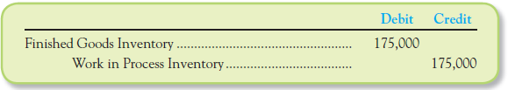

When the job is sold, the total cost is transferred from Finished Goods Inventory to Cost of Goods Sold. A journal entry is also made to record sales revenue. For example, if the Simpsons agreed to pay $275,000 for their home, accountants would make the following journal entries to record the sales revenue and cost of the home.

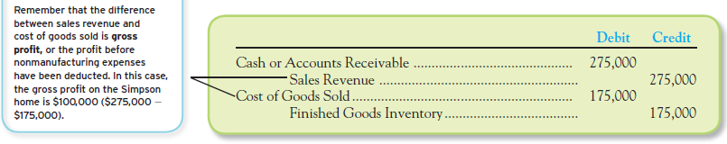

Recording Nonmanufacturing Costs

Unlike manufacturing costs, which are recorded in inventory until the product is sold; nonmanufacturing costs are expensed during the period in which they are incurred.

Assume Toll Brothers incurred the following nonmanufacturing expenses last month:

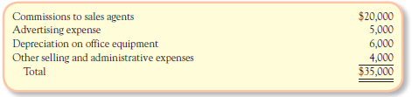
The journal entries to record these nonmanufacturing costs would be:
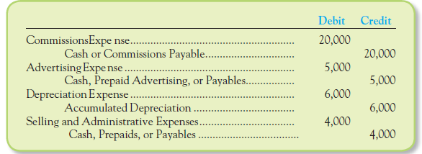
Overapplied or Underapplied Manufacturing Overhead

After recording the actual and applied manufacturing overhead in our home-building example, the Manufacturing Overhead account appears as follows:

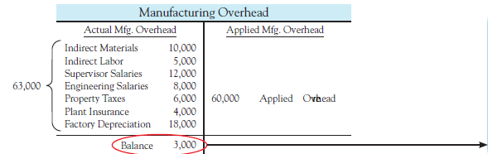
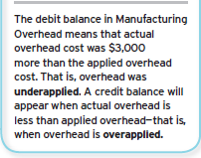
To eliminate the $3,000 debit balance in the Manufacturing Overhead account, we need to credit the Manufacturing Overhead account and debit the Cost of Goods Sold account. The journal entry to dispose of the underapplied overhead is:

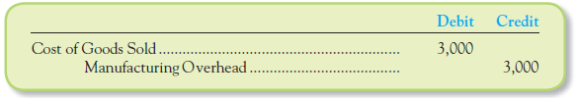
The effect of this entry is to increase the Cost of Goods Sold account by $3,000. If Manufacturing Overhead had been overapplied (with a credit balance), we would have debited the Manufacturing Overhead account to eliminate the balance and credited (decreased) the Cost of Goods Sold account.

CHAPTER SUMMARY

LO 1: Describe the key differences between job order costing and process costing.
- Process costing is used in companies that make homogeneous products using a continuous production process.
- Job order costing is used in companies that make unique products or provide specialized services.

LO 2: Describe the source documents used to track direct materials and direct labor costs to the job cost sheet.
- Direct materials are issued to production by using a materials requisition form showing the costs and quantities of all materials requested and the job they were used for.
- Direct labor costs are recorded using labor time tickets showing the amount of time workers spent on each specific job.
- The costs incurred for each job are recorded on a separate job cost sheet.

LO 3: Calculate a predetermined overhead rate and use it to apply manufacturing overhead cost to jobs.
- Because manufacturing overhead costs cannot be traced directly to individual jobs, we use an allocation base or cost driver to apply manufacturing overhead cost to specific jobs.
- The predetermined overhead rate is calculated by dividing the estimated total manufacturing overhead cost by the estimated value of the allocation base.
- Manufacturing overhead is applied to specific jobs by multiplying the predetermined overhead rate by the actual amount of the allocation base used on the job.

LO 4: Describe how costs flow through the accounting system in job order costing.
- Initially, raw material purchases are recorded in the Raw Materials Inventory account.
- When materials are placed into production, direct materials are recorded in the Work in Process Inventory account; indirect materials are recorded in the Manufacturing Overhead account.
- When labor costs are incurred, direct labor is recorded in the Work in Process Inventory account; indirect labor is recorded in the Manufacturing Overhead account.
- Actual manufacturing overhead costs are recorded on the debit side of the Manufacturing Overhead account.
- When manufacturing overhead is applied to specific jobs, the Work in Process Inventory account is debited and the Manufacturing Overhead account is credited.
- When a job is completed, the total cost of goods completed is transferred from the Work in Process Inventory account to the Finished Goods Inventory account.
- When the job is delivered to the customer, the total cost is transferred from Finished Goods Inventory to Cost of Goods Sold.
- Nonmanufacturing costs are recorded as period expenses rather than as part of the manufacturing cost flow.

LO 5: Calculate and dispose of overapplied or underapplied manufacturing overhead.
- Actual overhead costs are recorded on the debit side of the Manufacturing Overhead account; applied manufacturing overhead costs are recorded on the credit side. Thus, the balance in the Manufacturing Overhead account represents the amount of overapplied or underapplied overhead.
- If the overhead account has a debit balance, actual overhead costs were higher than applied overhead costs; that is, overhead was underapplied.
- If the overhead account has a credit balance, applied overhead costs were higher than actual overhead costs; that is, overhead was overapplied.
- At the end of the year, the remaining overhead balance is typically transferred to the Cost of Goods Sold account. Overapplied overhead decreases (credits) the Cost of Goods Sold account; underapplied overhead increases (debits) the Cost of Goods Sold account.

LO 6: Calculate the cost of goods manufactured and cost of goods sold.
- The total manufacturing cost that flows out of Work in Process Inventory and into Finished Goods Inventory is called cost of goods manufactured. When the product is sold, the cost is transferred to the Cost of Goods Sold account.
- Initially, the cost of goods manufactured and the cost of goods sold are based on actual direct materials, actual direct labor, and applied manufacturing overhead costs.
- The Cost of Goods Sold account is updated to reflect actual manufacturing overhead costs through an adjustment for overapplied or underapplied manufacturing overhead.

